

**St Nicholas GFC**

**Player Pathway**

**Coaching Manual**

**Under 12/14**

|  |
| --- |
| **Age Group – Under 12/14** |

**Learning about Positions**

**Player Characteristics:**

* While players in this stage may have the same chronically age they may differ significantly

in terms of biological age i.e. one may be more physically developed than another.

* The onset of puberty usually occurs during the early stages of this cycle. Aerobic and

strength programmes should be individualised or grouped according to their (P.H.V )

N.B Only trained coaches to undertake this training

* Broad base skills and sport specific skills
* Advanced technical skill development Skill developed under pressure
* Fitness with the ball in skills drills
* Gain an understanding of the principles of attack and defence through grids and small

sided games

* Players can be introduced to moderate anaerobic and strength training through ball work
* Players should be introduced to psychological training through games that promote

concentration and better decision making

|  |
| --- |
| **Age Group – Under 12/14** |

|  |  |  |
| --- | --- | --- |
| **Skill Emphasis** | **Physical (ABC & RJT’S)** | **Game Specific** |
| **Handling**  Ball feint  Fist pass for distance  Overhead tap on  Catching at speed  **Kicking**  Punt kick to moving target  Long kickpass  Scoring from angles  Assisted chip lift  Penalty kick  **Travelling**  Swerve  Change of pace with the ball  **Tackle**  Near hand tackle  Delay opponent and shadowing  Frontal tackle  Dive block  Hand off | **Speed**  Multi-directional (runs less than 20 secs)  Quick footwork and agility  Acceleration and deceleration  Game related reaction exercises  Relay racing *For Example:* Crazy ball Drills  **Strength**  Body weight circuit training (upper body, legs and back)  Develop core strength *For Example*: Plank  Learn correct weight lifting techniques  *For Example:* Squat, clean, snatch  Introduce free weights and medicine balls  NB: For upper age range only  Plyometric *For Example:* Multi directional jumps  **Stamina**  3 v 1 games  -drills incorporating the ball  **Flexibility/Coordination**  Maintain flexibility exercises  Dynamic warm up | **Part invasion**  Part-invasion games allow players to develop  positional sense and decision making with limited pressure from the opposition. *For Example:* Wide man, Zone to zone  **Full invasion**  The key element with invasion games is the  number of players involved. The less space a  player has, the less time he/she has, the more  skill is required. *For Example*: Backs v forwards,15 v 15  **Possession Games**  Concept games designed to correct a failing in  general team play or one rule games as they are known. *For Example*: Give and go, 4 second rule, 2 touch, Head up, First touch |

|  |
| --- |
| **Age Group – Under 12/14** |

**Key considerations at this level:**

* Training sessions should be enjoyable and inclusive of all players.
* It is important to build a good rapport with the players.
* Groups and teams should be divided evenly in terms of ability, age and gender.
* Review previous matches/sessions to establish areas to work on.
* Outline plans for each session to motivate players.
* Demonstrate the skills/drills slowly and speak clearly to the players.
* Keep drills short and varied so that players remain focused throughout the training session.
* Players should use **both hands and both feet** when learning new skills and playing games.
* Coaches should encourage players, acknowledge their effort and praise them regularly.
* Give time at the end of a session to reflect with the players on the quality of the training session.
* Encourage players to practice their skills at home.
* The sample sessions provided focus on three skills in each session. Each skill develops further as sessions progress. Coaches are encouraged to build their own sessions, varying the skills focused upon and addressing the needs of the players.
* Additional activities are included to show how each skill can be developed further.

**Duration of training session: 75/80 minutes**

**Equipment/Resource List:**

* Each player should have a bib (different colours for opposing teams).
* 1 ‘Smart touch’ football between two players.

* Coach/player ratio: 1:6.
* 1 set of training cones/1 set of training poles.

* 1 set of water bottles.

* Sets of goal posts (15ftx7ft).
* Whistles for coaches/referees for games.
* Go Games rules applied.



* 11-a-side games.
* Game duration– 2 halves of 20 mins per half.
* First Aid bag.

**Pitch Dimensions:**

* 90 meters x 40-50 meters

* No zones

|  |
| --- |
| **Under 12/14 – Sample Sessions** |

**Sample Session 1**

**Key Skills – Punt Kick 2, High Catch & the Roll**

**Session Structure Duration**

Warm up 10 mins

Introduce the focus of the session 5 mins

Partner Catch 10 mins

Partner Roll 10 mins

Partner Kick 10 mins

Game – 11v11 25 mins

Cool Down 5 mins

Session Review and Conclusion 5 mins

**Sample Session 2**

**Key Skills – Punt Kick, High Catch & The Roll**

**Session Structure Duration**

Warm up 10 mins

Introduce the focus of the session 5 mins

Along the Line (Punt Kick Drill) 10 mins

Move and Block 10 mins

Grid Roll 10 mins

Game – 11v11 25 mins

Cool Down 5 mins

Session Review and Conclusion 5 mins

|  |
| --- |
| **Under 12/14 – Sample Sessions** |

**Sample Session 3**

**Key Skills – Punt Kick 2, High Catch & the Roll**

**Session Structure Duration**

Warm up 10 mins

Introduce the focus of the session 5 mins

Turn and Kick 10 mins

Move and Catch 10 mins

Dancing Feet (The Roll Drill) 10 mins

Game – 11v11 25 mins

Cool Down 5 mins

Session Review and Conclusion 5 mins

**Sample Session 4**

**Key Skills – Near Hand Tackle, Feint & Side Step**

**Session Structure Duration**

Warm up 10 mins

Introduce the focus of the session 5 mins

On the Ball 10 mins

Around the Man 10 mins

Tackle to Team-Mate (NHT Drill) 10 mins

Game – 11v11 25 mins

Cool Down 5 mins

Session Review and Conclusion 5 mins

|  |
| --- |
| **Under 12/14 – Sample Sessions** |

**Sample Session 5**

**Key Skills – Near Hand Tackle & Feint and Side Step**

**Session Structure Duration**

Warm up 10 mins

Introduce the focus of the session 5 mins

Around the Block 10 mins

In and Out 10 mins

1,2,3 Feint (2nd Feint and Side Step Drill) 10 mins

Game – 11v11 25 mins

Cool Down 5 mins

Session Review and Conclusion 5 mins

**Sample Session 6**

**Key Skills – Reach Catch, Block Down & Hook Kick**

**Session Structure Duration**

Warm up 10 mins

Introduce the focus of the session 5 mins

Hand Pass Drill 10 mins

Kick Pass Drill 10 mins

4 Mini Games – Hand Pass Possession 10 mins

Game – 11v11 25 mins

Cool Down 5 mins

Session Review and Conclusion 5 mins

|  |
| --- |
| **Under 12/14 – Introduction** |

**The skills outlined here have been identified as appropriate for players under the age of 12. Remember that some players progress quicker than others and may have already mastered a number of these skills.**

**Punt Kick**

The Punt Kick is a foot passing technique used in Gaelic Football. It may also be used to kick for a score when approaching the goal straight on.

**High Catch**

The High Catch is one of the most spectacular techniques in Gaelic Football and is used to field the ball from the air. It is used in particular to win possession from a kick out or long pass.

**The Roll**

The Roll is an evasion technique used in Gaelic Football when the player in possession goes into contact with an opponent. To perform the technique the player in possession uses the contact to roll away from the opponent and change direction.

**Near Hand Tackle**

The Near Hand Tackle is a tackling technique in Gaelic Football used to knock the ball from an opponent’s possession with the open hand.

**Feint and Side Step**

The Feint and Side Step is a technique used to evade an opponent while in possession of the ball or to lose an opponent in order to find space. The objective of the technique is to disguise the intended direction of movement in order to move into a more advantageous position.

|  |
| --- |
| **Under 12/14 – Warm Up Drills** |

**Warm Up Drill 1**

**Organisation:**

* 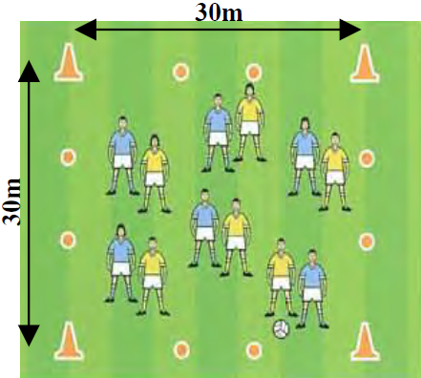Line out a square 30m x 30m.
* All players run around inside the square.
* Use all balls for hand passing (left and right hand).
* After a period of time, throw the ball for catching.
* After another while roll the ball for your partner to crouch lift and solo (alternate both sides).

**Warm Up Drill 2**

**Organisation:**

* Set up a line of cones 40m apart.
* Players line up at both ends.
* Players hand pass the ball to the oncoming player as they cross over the cone line.
* Continue to the back of the opposite line and start again

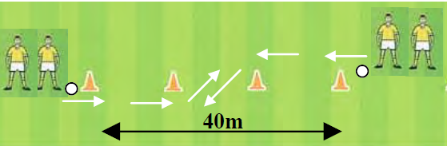

|  |
| --- |
| **Under 12/14 – Punt Kick 2** |

**Key Teaching Points**

* Hold the ball firmly with both hands

Head down, eyes on the ball

* Release the ball into the hand at the kicking side and extend the opposite arm away from the body to aid balance
* Step forward with the non-kicking foot

Extend the wrist and drop the ball onto the kicking foot

* Kick the ball with the instep, that is, the laced part of the boot
* Keep the toes pointed

Follow through in the direction of the target

**Common Errors**

* Lifting the head too early: this can lead to mis-kicking the ball and sending the ball in the wrong direction
* To correct, continue to keep the head down, focusing on the point of impact until the follow through is complete
* Dropping the ball from the opposite hand to the kicking foot: this can lead to the player kicking the ball with the inside of the foot and misdirecting the pass or shot
* To correct, drop the ball from the hand at the kicking side and extend the opposite arm away from the body to aid balance
* Not keeping the toes pointed and not following through in the direction of the target
* To correct, keep the toes pointed throughout the kick, following through in the direction of the target

|  |
| --- |
| **Under 12/14 – Punt Kick 2** |

**Practice the Technique**

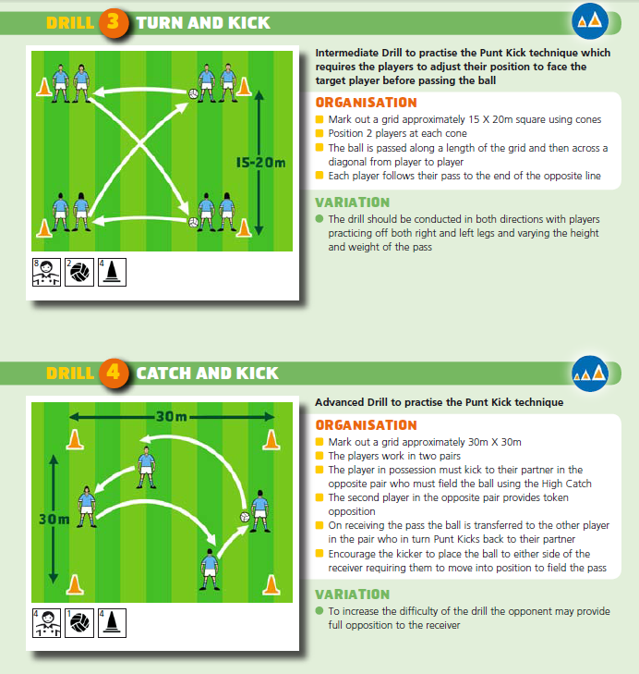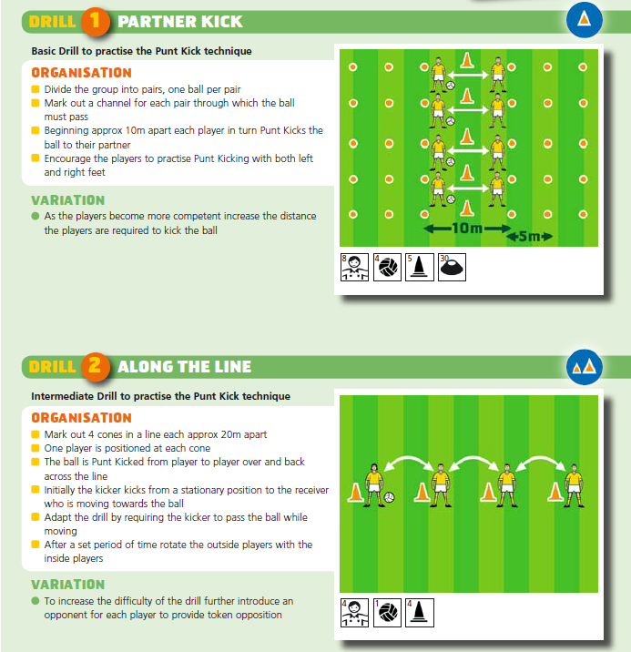

|  |
| --- |
| **Under 12/14 – Punt Kick 2** |

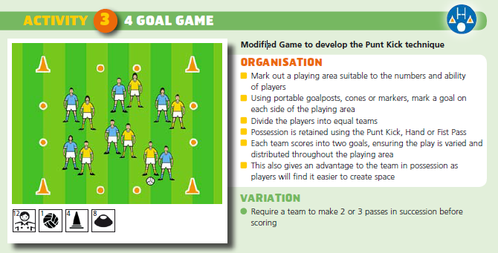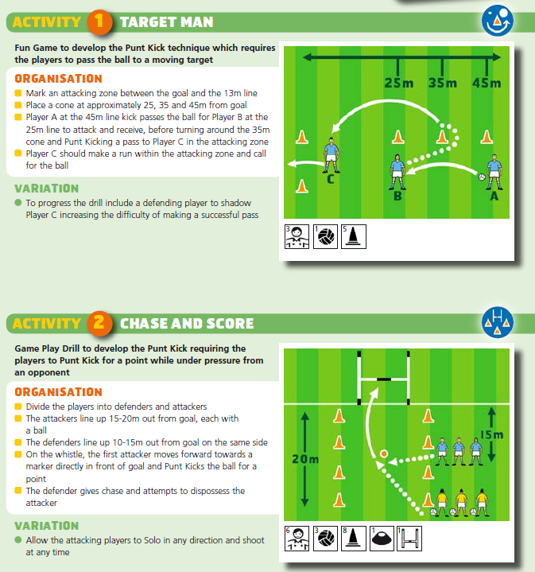**Develop the Skill**

|  |
| --- |
| **Under 12/14 – High Catch** |

**Key Teaching Points**

* Adopt a starting position down the line of the oncoming ball

Approach the ball as it begins to descend

* Moving forward, plant the jumping foot and extend upwards, swinging the opposite leg forward
* Extend the arms fully above the head

Head up, keep eyes on the ball

* Spreading the fingers to form a ‘W’ shape behind the ball, catch the ball slightly in front of the head
* Cushion the ball and secure to the chest with both hands

**Common Errors**

* Not swinging the non-jumping leg forward: this may result in the player not jumping to their full potential and being out fielded
* To correct, swing the opposite leg forward as they begin their jump
* Not extending the arms fully: this may result in the ball being intercepted in a game situation as the player fails to take the ball at the highest possible point
* To correct, extend the arms fully towards the ball as it approaches
* Not securing the ball into the chest: this may result in the ball being knocked from the players hands as they land
* To correct, secure the ball to the chest with both hands
* Jumping too early or too late: this may lead to the player missing the catch or leaving the ball open to interception
* To correct, watch the flight of the ball closely, jumping to catch the ball at the highest, safest point

|  |
| --- |
| **Under 12/14 – High Catch** |

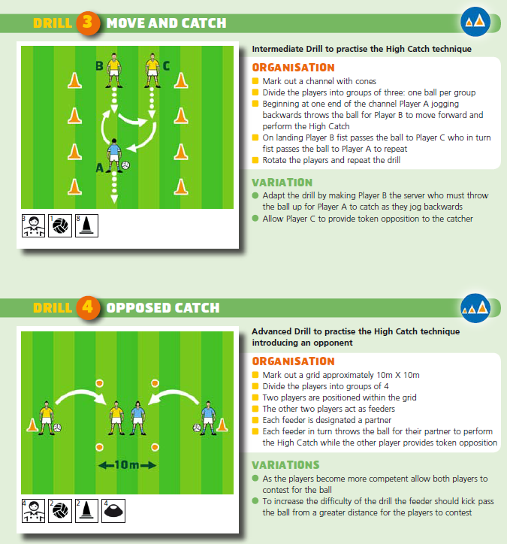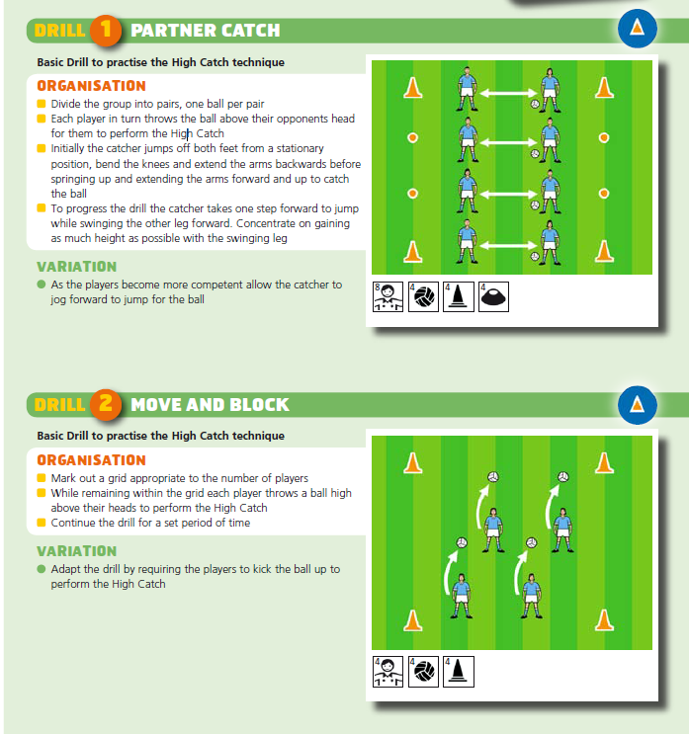**Practice the Technique**

|  |
| --- |
| **Under 12/14 – High Catch** |

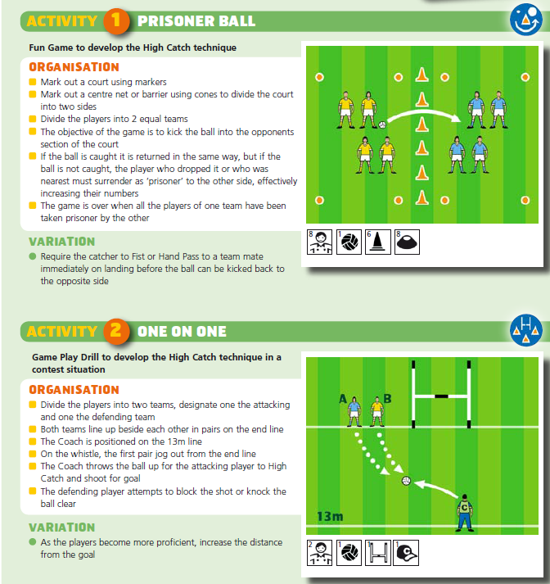**Develop the Skill**

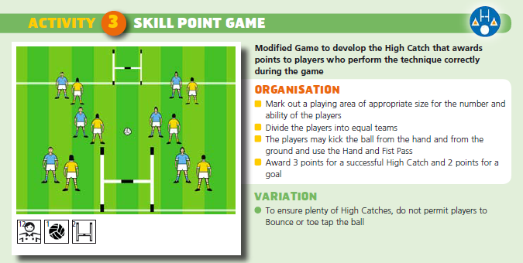

|  |
| --- |
| **Under 12/14 – The Roll** |

**Key Teaching Points**

* Run directly towards the opponent
* Plant the right foot forward, towards the opponent’s left shoulder while transferring the ball to the left side
* Engage the opponent in a Side to Side Charge

Using their shoulder as a hinge, roll off by swinging the left leg

around and pivoting on the right foot

* Plant the left foot on the ground and transfer the ball back to the outside of the body, now on the right side
* Bring the right leg around and accelerate away

Use a low bounce clearing the opponent

**Common Errors**

* Using a bounce as opposed to a toe tap going into the tackle; this may result in the player fouling the ball coming out of the tackle as they must toe tap the ball and may not have sufficient time or space
* To correct, toe tap the ball when in space approaching the opponent
* Planting the ‘wrong’ foot and leading off the wrong shoulder
* To correct, plant the opposite foot to that of the opponent, as in a Side to Side Charge
* Rolling across the front of the opponent: this may also leave the ball exposed to a tackle
* To correct, plant the opposite foot to that of the opponent and roll back to back with their opponent
* Not protecting the ball during the tackle: this may result in the opponent knocking the ball away
* To correct, continue to transfer the ball to the outside of the body throughout the tackle

|  |
| --- |
| **Under 12/14 – The Roll** |

**Practice the Technique**

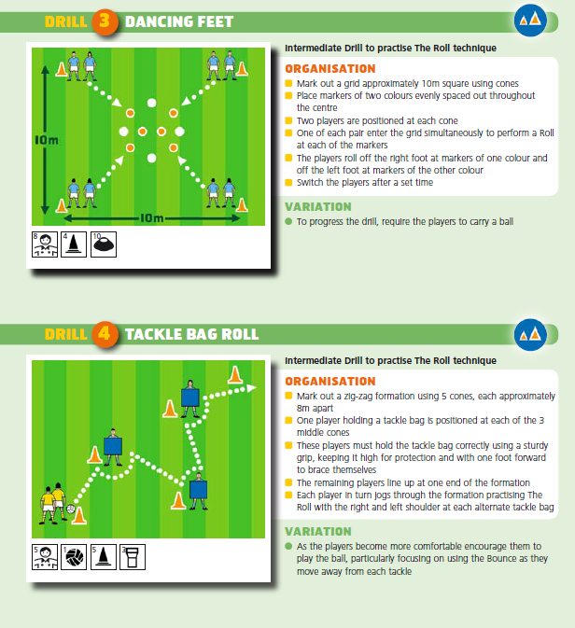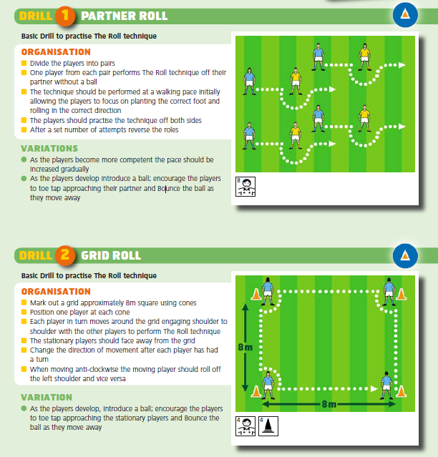

|  |
| --- |
| **Under 12/14 – The Roll** |

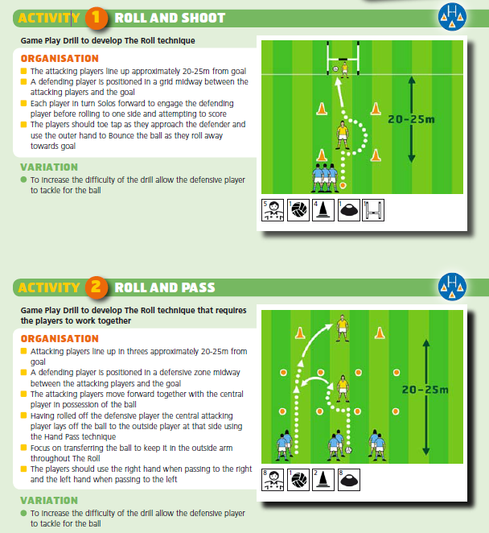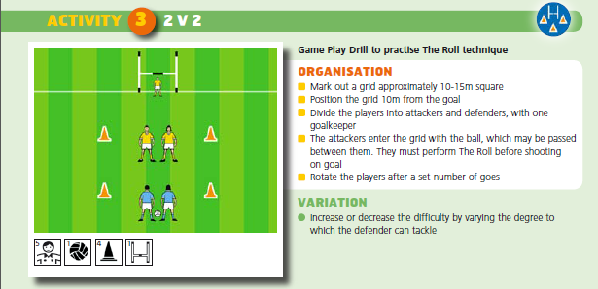**Develop the Skill**

|  |
| --- |
| **Under 12/14 – Near Hand Tackle** |

**Key Teaching Points**

* Move alongside or level with the opponent

Keep eyes on the ball

* When the opponent’s far leg is forward step across their space with the near leg
* Flick the ball away with the hand nearest the opponent when the ball is free in the solo or bounce
* Recover the ball to win possession

**Common Errors**

* Tackling from behind by not getting the shoulder with the opponent: the may result in the player fouling their opponent by pushing or charging them in the back
* To correct, make ground to be level with the opponent before making the tackle
* Leading with the outside leg and hand: this leads to poor balance and may result in the near hand being placed on the opponent’s back or used to pull the opponent back thus committing a foul.
* To correct, step in with the near leg and hand when the opponent’s far leg is forward
* Not targeting the ball leads to the player committing an aggressive foul by pushing, pulling or charging his opponent
* To correct, remain disciplined, keeping the eyes focused on the ball at all times
* Not timing the tackle to coincide with the ball being free: this may make the tackle more difficult to complete and may again lead to the player committing a foul
* To correct, be patient and focus on the instant the ball is played by the opponent in an attempt to bounce, toe tap or pass

|  |
| --- |
| **Under 12/14 – Near Hand Tackle** |

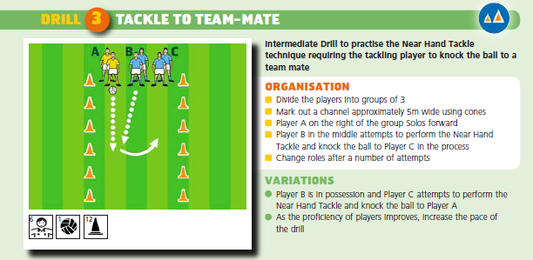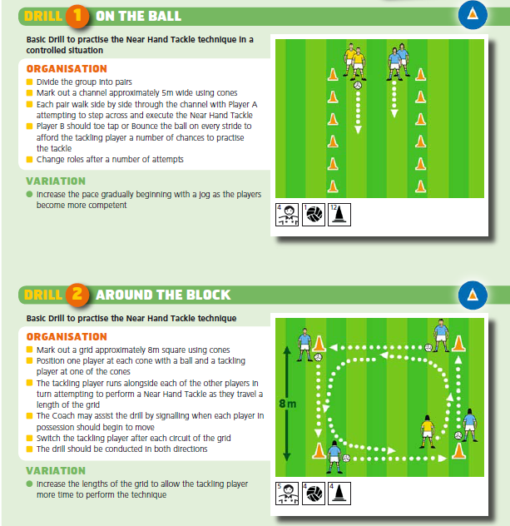**Practice the Technique**

|  |
| --- |
| **Under 12/14 – Near Hand Tackle** |

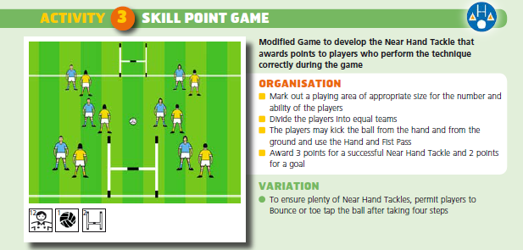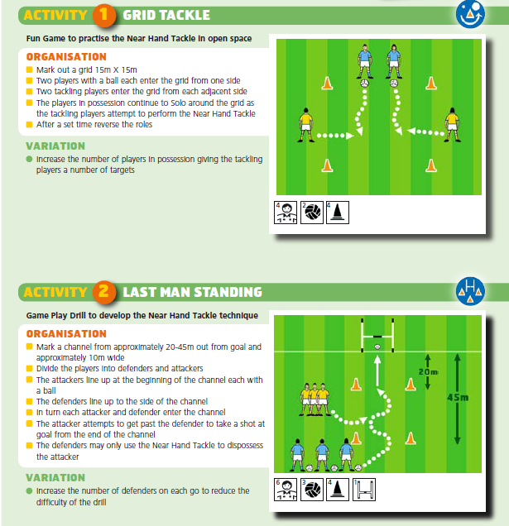**Develop the Skill**

|  |
| --- |
| **Under 12/14 – Feint and Side Step** |

**Key Teaching Points**

* Run directly towards the opponent
* Feign movement to one side by shifting body weight in that direction

Accentuate the feint by dropping the shoulder at that side simultaneously

* Quickly change direction by shifting your body weight back and pushing hard off the planted foot

When using a ball, the feint may be further accentuated by showing the ball before pulling the ball back rapidly as you change direction

* Accelerate quickly away

**Common Errors**

* Stepping to one side to plant the foot too early: this may allow the opponent to read the intention of the movement and recover quickly
* To correct, move to 1 to 2m from the opponent before beginning the feint
* Not transferring to one side
* To correct, feign movement to one side by shifting body weight in that direction and dropping the shoulder to the same side
* Accelerating away too slowly after changing direction: this may result in the player failing to lose their opponent
* To correct, concentrate on moving away from the opponent as quickly as possible after changing direction
* Showing the ball too early: this may allow the opponent to read the intention of the movement and recover quickly
* To correct, move to 1 to 2m from the opponent before beginning the feint

|  |
| --- |
| **Under 12/14 – Feint and Side Step** |

**Practise the Technique**

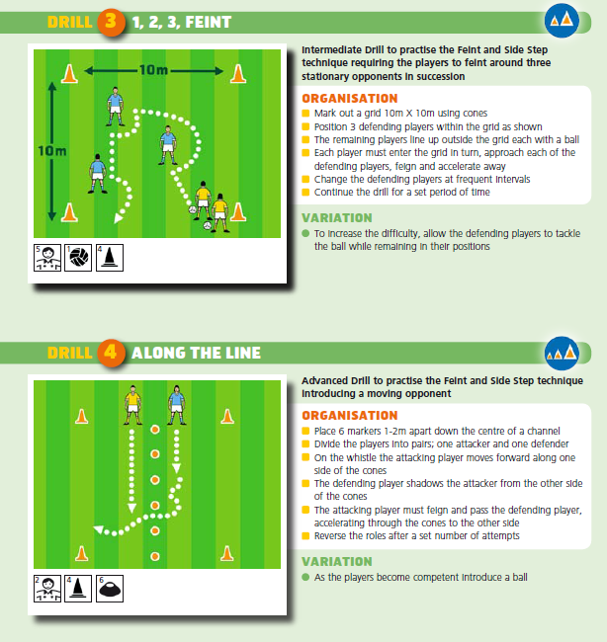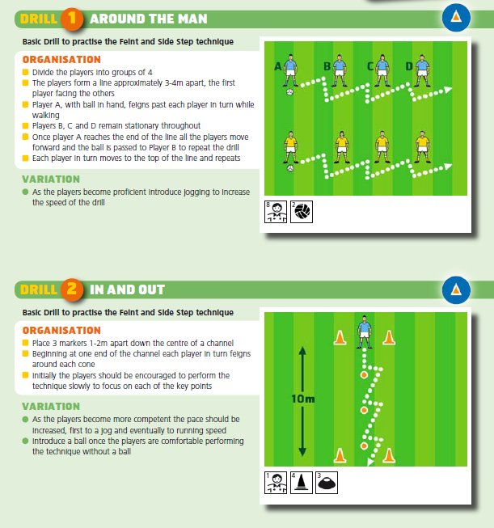

|  |
| --- |
| **Under 12/14 – Feint and Side Step** |

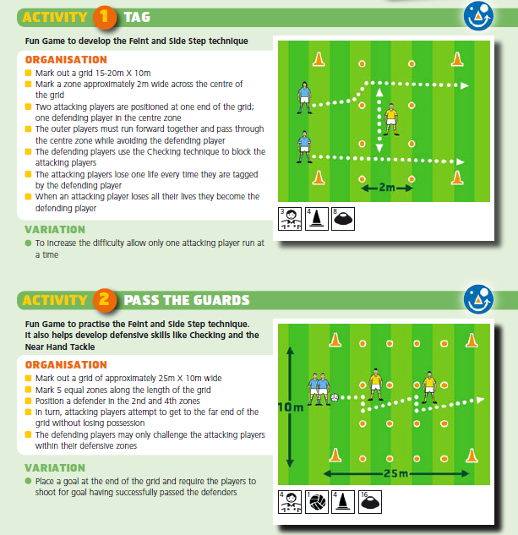**Develop the Skill**

