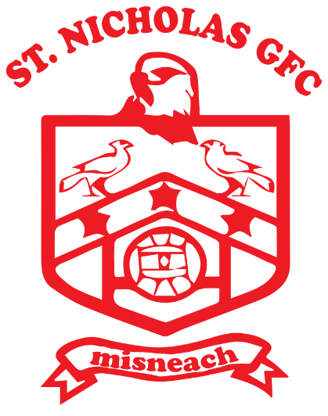

St Nicholas GFC
Player Pathway
Coaching Manual
Nursery
Age Group – Under 4-6

Learning to Master the Ball

Player Characteristics:
- Children of this age are self-centred and co-operation is largely absent.
- Un-coordinated and individually focused
- At this age many still think that the ball is their own ‘toy’, so they will try to run with the ball and score rather than pass.
- They will respond to partner work and skills practice for a short time. This helps introduce them to team work and co-operation.
- These children will only watch the ball. They cannot and will not look for space to run into.
- They usually enjoy being asked questions and this should give the coach plenty of opportunities to check for understanding.
- When their team is not in possession they find it difficult to understand defending a goal. To them they are merely chasing a ball.
- They respond best to target games and races (hitting, throwing and running).

Age Group – Under 4-6

Skill Emphasis | Physical (ABC & RJT’S) | Game Specific
Handling  Throw  -bowling ball  -2 handed bounce catch  -one hand bounce  Body catches  Pick up stationary and moving.  Kicking  Ground kick  Dribble  Punt kick (two hands)  Travelling  Knee tap solo | Agility  For Example: Chasing games, Dodging, Shadow running  Balance  For Example: Animal walking, hop in and out of hoops  Coordination  For Example: Skipping, Beanbag toss, Over and under in a line  Running  Good technique (forward, backwards, sideward)  For Example: Marching Stopping  Jumping  For Example: Take-off and landing, Jumping jacks  Throwing  For Example: Target roll | Target games  The simplest form of a game which challenges players to use the techniques previously learnt is to aim into or at a target. Players have lots of time to perform the task without any distraction from other players. There is a low level of decision making. For Example: Skittles, Through the gate, Tower ball  Court games  Court games require players to pass the ball over an obstacle like a net or zone to a receiver. The level of decision making has increased but is limited. For Example: Over the river, Hurling tennis  Part-invasion  These games require players to complete a task with limited or direct opposition. For Example: Getting through the traffic, 4v4 (two zones) no goalie, Up north down south

Age Group – Under 4-6

Key considerations at this level:

- Training sessions should be enjoyable and inclusive of all players.
- Coaching style is a very direct style where coach explains all the skills required with clear demonstrations, creating opportunities to practice the skills and observes them providing some feedback.
- Coaches should encourage players, acknowledge their effort and praise them regularly.
- This age copy what they see, the best method here is through active demonstration - you act, they follow!
- It is important to only introduce one thing at a time with this age group.
- Aim is to get kids and their parents involved in St Nicholas GFC
Duration of training session: 60 minutes
Equipment/Resource List:

- Each player should have a bib (different colours for opposing teams).
- 1 ‘First touch’ football between two players.
- Coach/player ratio: 1:6.
- 1 set of training cones.
- 1 set of training poles.
- Bean Bags/Tennis Balls
- 1 set of water bottles.
- Whistles for coaches/referees for games.
- First Aid bag.
Under 4-6 Introduction

Participation & game enjoyment. Primary development is Fundamental Movement Skills (ABCs +RJTs) relevant to learning the technical skills of GAA games, achieved by developing FMS through simple fun games and play, starting without and progressing to include a ball.
Agility
The ability to move and change direction, avoiding obstacles and each other. The ability to dodge and move off both feet.
Use tag type/chasing fun games.
Balance
The ability to hold different stances and hold static (stationery positions, 2 feet, 4 points i.e. animal stances).
Develop from 2 legs to single leg, and with ball in hand.
Co-ordination
Ability to move in various ways – running in different directions, side to side, low skipping. Also with objects, bean bag toss, through hoops etc. Do in fun games with plenty of space, caution not to add ball too early.
Running
Basic technique including stopping and starting. Focus on the fundaments of running such as using the arms and legs and moving forwards and backwards.
Jumping
This is key for future advanced skill development – taking off/landing with two feet. Advance to taking off one foot and land two footed. Do not add ball at this stage.
Throwing
Start with rolling for self and target rolling. Different hand positions on ball. Advance to rolling in pairs before development into throwing.
Under 4-6 Introduction cont.

The skills outlined here have been identified as appropriate for players under the age of 6. Remember that some players progress quicker than others and may have mastered these skills. In this case progress to the skills outlined in the U-8 section of this resource.

Handling (Bilateral – LEFT & RIGHT)
- Pick up a stationery ball (2 hands) & set down
- Scoop Pick up
- Bowling the ball individually
- Tummy throw individually
- Individual two handed catching (low, body & high catch)
- Bounce to self & catch
- Full air borne body/high catch
- **Introduce hand passing – left & right

Kicking (Bilateral – LEFT & RIGHT)
- Dribbling ball on ground with feet – left & right
- Trapping a moving ball with foot – left & right
- Ground kicking individually – left & right
- Bounce kicking individually – left & right
- **Introduce kick passing/punt kicking – left & right

Travelling (Bilateral – LEFT & RIGHT)
- Fundamental Movement Skills (without ball, move to extension with ball)
- **Introduce stationary solo – left & right

** Only begin to introduce & develop these skills if competent & confident in all other FMS leading to this!

Under 4-6 Sample Session 1

Theme of Session: Ball Familiarisation

Warm up: General Mobilisation
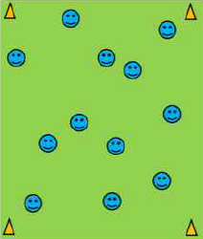
-Children move around the square in different directions
Teaching Points
Change Direction
Head Up
Use Animals as examples of movements to us

-Ask the children to preform different movements such as Side to Side, Heel Flicks, High Knees, Knee Up & Out, Knee Out & In, Backwards (Walking), Hopping etc..

Pulse Raiser: Spiders & Flies
Teaching Points
Head Up
Stay inside the Square
Work as a team
Make it competitive (Which team can catch most flies)
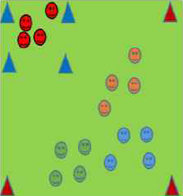
-Divide group into teams of 4/5.
-One of the teams is the Spiders (Reds)
-The rest of the teams are the flies (Orange, Blue, Green)
-Spiders have 45 seconds to catch as many flies as possible
-Spiders take caught flies to their ‘Web’ which can be seen with blue cones

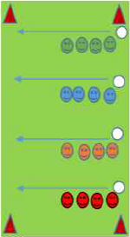
Speed/ Skill Development: Human Tunnel Ball
-Keep same teams as previous game
-Each team forms a line as shown
Teaching Points
Wide Fingers
Eyes on ball
Hug Ball
Big Hands Catch

-First child at the front of each team has a ball
-First child passes the ball down the line by handing the ball to the next player in line (not throwing allowed)
-Once a player hands ball over, they sprint to the back of the line
-Team that gets all members over line 1st wins.
Variations: Pass ball Overhead/Underlegs
Fun Game 1: Switch Ball
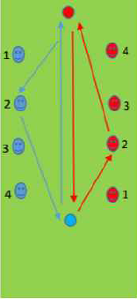
-In same teams, set up following game twice. (Blue v Red, Orange v Green)
Teaching Points
Focus
Carry ball in both Hands
Only award point if ball is set in hula hoop
-Give players on each team a number in exact sequence as shown (1-4)
-Coach call number (3) and the no.3 from each team follows arrows as shown, they pick up ball and set it down on opposite side.
-Player that gets back to start position 1st wins a point.
-Team with most points wins.
Variations:
- Players bounce ball at least twice
- Players throw to two of their team mates
- Players weave in and out through team

Skill Card: Ball Familiarisation
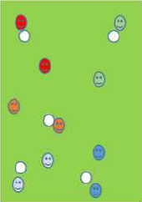
- Underarm Throw &Body Catch
Teaching Points
Eyes on the ball
Big Hands Catch
Feet: one foot forward, one behind
- Underarm throw & body catch, Stationary-Walk-Jog
- 10 Up Catch – Player throws ball up & catches 10 times in a row
- Throw Ball up, clap hands and Body Catch
- Figure 8 around the legs
- Circle ball around body
- Hand bouncing
- Hand bouncing on the move

Fun Game 2: Fun Relay Races
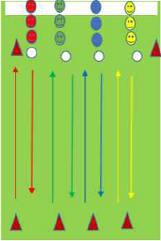
-Divide into group of 3 max. Teams in a line, first person in the line with a ball
Teaching Point
Eyes on the ball
Bounce ball in front of yourself
Look at target
Bring ball into body after catching (digger/hug)
-First person runs out and bounces ball out and around cone 10M out
-Player comes back and underarm throws to next player who catches and repeats
-Each player goes 5 times
-Use Ball Familiarisation exercises from previous drill

Variations:
Player throws ball up and catch
Players roll ball out to cone
Players roll ball out with strong hand and back with opposite hand

Under 4-6 Sample Session 2
Theme of Session: Kicking One
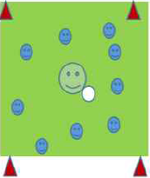
General Mobilisation: Coach tag
- Coach in centre has ball, calls various commands such as high knees, flick heels, side to side, skipping, jump for height, jump for distance
Teaching Points
Head up
Eyes on coach

- Coach puts ball over head, players must exit square as quickly as possible
- Coach puts ball back and players come back into square

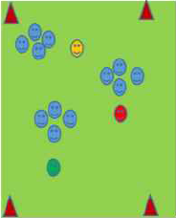
Pulse Raiser: Circle Tag
-Divide children into groups of 6, numbers 1 – 6
Teaching Point
On balls of feet
Work as a team
Quick feet

-1 - 5 join hands in a circle, 6 stays out
-1 tucks bib into side of shorts
-No. 6 then attempts to get the tail off one
-Circle can move around while holding hands to prevent chaser getting the tail. Chaser not allowed inside circle

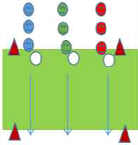
Speed/ Skill Development: Kick Relays
- Two teams
Teaching Point
Call Name
Head: Over the Ball
Hands: Use for balance
Feet: Using inside of foot when dribbling

- Players dribble ball up to cone and kick ball to next player
- First team to have each player gone 5 times wins
Progression
- Pass using non-dominant foot
- Punt Kick Relays

Main Body of Session
Whole/Part/Whole Method
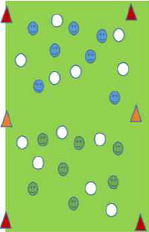
Game 1: Empty the Square
-Two Teams
-High number of balls in each half of a court
Teaching Points
Focus on looking for space
Follow through with foot when kicking

-Aim is for players to empty their half of the court of balls
Variations
- Use of non-dominant foot only
- Player who receives ball must play a one-two with team mate before returning the ball
Progression
- Increase size of squares
- Introduce punt kick into space

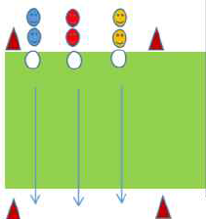
Skill Development: Kick Fada
- Get players into their pairs on the start line, with one ball between them
Teaching Points
Head: Eyes on ball
Hands: Ball rolls off the shelf
Feet: Kicks through ball with laces

- Player 1 in each pair kicks the ball out as far as he/she can
- Player 2 then kicks as possible from the position the ball landed
How many kicks does it take to get a certain target?

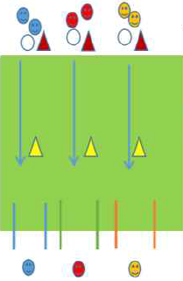
Skill Development: Catch & Kick if You Can
-Divide players into groups of 3
Teaching Points
Look at Target

Head: Focus on Ball

Hands: Both Hands on Ball, drop to foot

Feet: Kick with laces. Toe down

-One player stands behind goals as shown
-Player at the start line carry’s ball until yellow cone
-At yellow cone player attempts to kick the ball through the poles
-Player behind goals gets ball and joins group at red cone
-Player that kicked ball, replaces player behind the poles
Progression
- Second player applies token pressure to kicker

Game 2: Kick Rounders
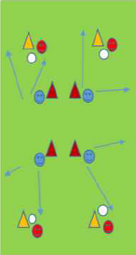
-In Pairs (Red & Blue)
-Red player handpasses/throws ball to Blue player
Teaching Points
Look for space
Kick ball into the space

-Blue player kick ball as far as possible in any direction
-Blue player comletes as many shuttle runs as possible between the red and orange cone
-Blue player kicks three times and the changes with opposite Red player

Progression
- Use non-dominant foot
- Introduce second player on fielding team and introduce team play

Under 4-6 Sample Session 3
Theme of Session: Hand Pass
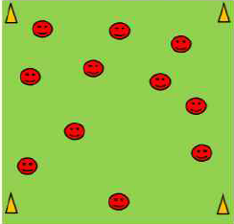
Warm up: General Mobilisation
Teaching Points
Don’t follow anyone
Introduce idea of finding space

- Children move around the grid in different directions
- Ask the children to come up with different ways of moving. Use animals as examples.
- Try to get them to move in double legged, single leg, hopping, skipping movements

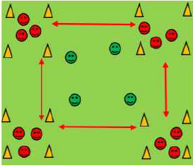
Fun Chasing Game: Cats & Mice
- Cats (Green) have to try & catch the mice (Red)
Teaching Points
Timing of run
Max stay of 3 secons in Den after coaches call

- The 4 squares are the mice dens, a cat cannot enter the dens
- On the coaches call all the mice have to move to a different den
- If a mouse catches them they become a mouse

Skill Introduction: Hand Pass
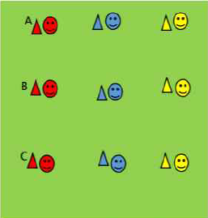
-Player divide into groups of 3, with 1 person stationed at either cone A, B or C
Teaching Points
Head: Eyes on ball
Hands: Lean forward
-Strike through middle of ball using palm of hand
Feet: Opposite foot forward to striking hand

-A & C both have a ball
-B runs towards A. A hand passes to B. B returns pass to A.
-B then turns and runs towards C and repeats the process.
-Switch roles
Progression
- How many passes inside 1 minute?

Main Body of Session
Whole/Part/Whole Method
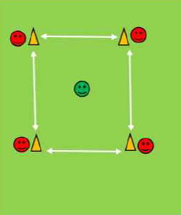
Whole Part One: Piggy in the Middle
Teaching Points
Head up looking for a teammate
Talk to each other
Signal where you want the ball to go
-In groups of 5 (Use the grid from Cat & Mice)
-4 players at outside cones, with One player in the middle.
-Players on outside have a ball and pass between each other
-Player in middle is trying to intercept the ball.
-Player keeps account of how many interceptions the get
-Every player gets a go in the middle

Part Game One: Bowling (Beginners)
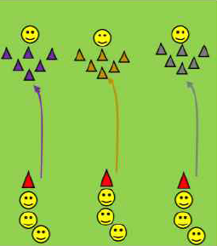
- Players get into groups of 4 and line up as shown with 3 behind cone and one behind ‘bowling pins’
Teaching Points
Follow through (in direction of bowling pins)
Lean forward
Head over ball

- Players at cones take it in turn to roll the ball underarm at the bowling pins, trying to knock as many as possible
- Player behind the bowling pins rolls the ball back to the group for the next person
- Switch roles

Part Game Two: Through the Goals
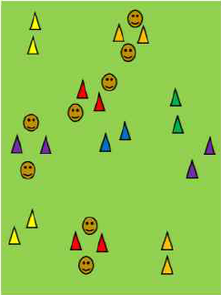
-In partner, plyers have to hand pass the ball through a set of goals to their partner.
Teaching Points
Head Up
Looking for free goals

-After they have completed the pass, they move to a different set of goals
Progression
- How many completed passes in one minute
- Make it a double pass for each goal (Player passes to partner, partner passes the ball back)
- Non-dominant hand

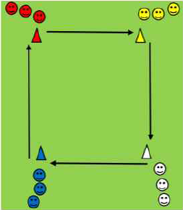
Part Game Three: Around the Square (Relay)
-Divide group into 4 teams as shown
Teaching Points
Players not running stand back from cone to give players a chance of running around cones

-One ball per group
-One player from each team starts the race
-They run with the ball in the direction shown around the grid
-When they make it back to own group, player hand passes the ball to next player in line and they go

Whole game Two: Piggy in the Middle
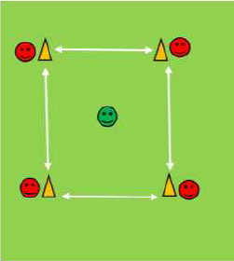
-Same as Whole Game One
Teaching Points
Better execution than first game
Players moving, not staying at the same cone

Variations
- Players on outside cones can move along the line, instead of just staying at their cone
- If a players pass get intercepted the become the ‘Piggy in the Middle’

Under 4-6 Sample Session 4
Theme of Session: Kicking 2 / Shooting
Warm up:
General Mobilisation: Shadow Run
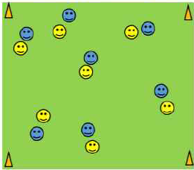
-In pairs, (yellow & blue)
Teaching Points
Let kids decide different movements themselves

-Yellow is in control
-Blue has to follow yellow everywhere he goes
-Encourage yellow to move in different ‘fun’ ways. Blue must copy them
-Swap roles

Chasing Game: Toilet Tag
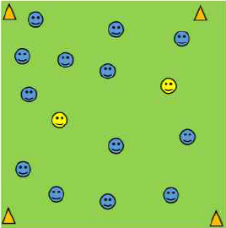
-Two players are the tagger, remaining players can be caught.
Teaching Points
Stay inside the playing area

-If a player is tagged, they have to go into the squat position with one of their arms straight out to the side
-They can be released with a free player pushing their hand down (Flushing the toilet)
-Change taggers

Speed Development & Skill Introduction: Kicking
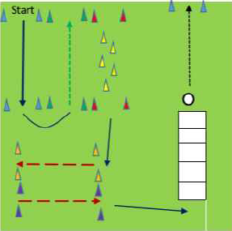
-Players move through the following grid.
Teaching Points
Knees Up
Plant Outside Foot
Use arms
Quick Feet

-Colours show you the movement that should be used
-Blue Arrow = Forward
-Broken Green Arrow = Backward
-Broken Red Arrow = Side to Side
-Yellow Cone = Slalom through
-Players go through ladder (hop-scotch) and attempt to kick ball through cones to finish exercise

Main Body of Session
Station Method
Dribble & Shoot
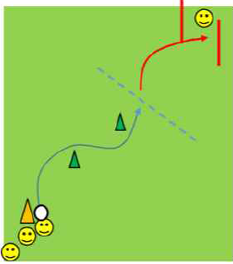
-Player at orange cone dribble the ball around green domes
Teaching Points
Split group in even numbers with each group going through the different station set up
Eyes on ball
Close control
-When they reach blue line, they stop/ trap the ball
-Player then strikes for a goal between 2 poles
-Player behind goals picks up the ball & joins the back of cue at orange cone
-Player that kicked ball goes behind poles

Through the Gates
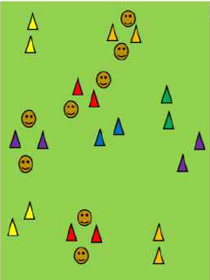
In pairs player have to kick pass the ball through a set of goals to their partner
Teaching Points
Pass & Move
Call Name

After they have completed the pass they move to a different set of goals
Progression
- How many completed passes in one minute
- Make it a double pass for each goal (Player passes to partner, partner passes ball back)

Hurdle & Blast
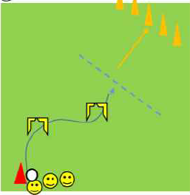
-Player at the red cone dribble a small ball under the hurdles as shown
Teaching Points
Close ball control
Eyes on the ball
Aim for back of Cones

-When they reach the blue line, they pick up the ball
-They attempt to knock one of the tall cones in front of them
-They collect their ball and re-join group

Wall/ Goal Targets
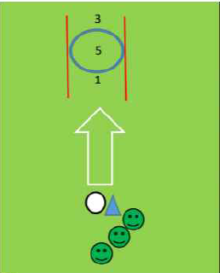
-Use wall to mark out targets or hoops attached to poles
Teaching Points
Toe Down
Head Down eyes on call
Face Target

-Players take it in turns to punt kick the ball at the target hoop behind the cone
Progression
- Use weak foot
- Move kicking distance closer/ further away from wall depending on level or group

No Man’s Land
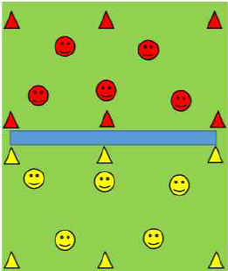
-Two teams
Teaching Points
Head Up
Look for Space
Pick Target
Make sure all players get a chance to kick the ball

-Players attempt to kick the ball over the river (blue area) into the other team’s area
-Team gets awarded one point for every time they kick the ball into the other team’s zone

Under 4-6 Sample Session 5
Theme of Session: Handling
Warm up: General Mobilisation
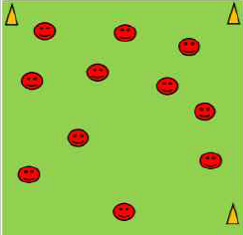
- Children move around grid in different directions
Teaching Points
Don’t follow anyone
Introduce idea of finding own space

- Ask the children to come up with different ways of moving. Use animals as example
- Try to get them to move in double legged, single leg, hopping, skipping movements

Chasing Game: Tail Tag
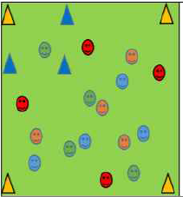
-Every child has two bibs each
Teaching Points
Heads Up
Find Space
Stay inside Space

-Games last for 1 minute
-See how many bibs you can get off other players in that one minute
-You must go to the den (blue square) when you get a bib, put it on & return to the field of play
-If you lose both your bibs you can continue getting other children’s bibs

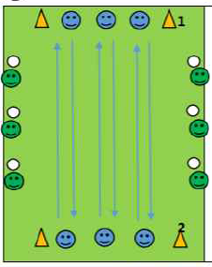
Fun Game: Roller ball
-6 Throwers (Green) stand in position shown.
Teaching Points
Throw the ball underarm
Time Run

-Everyone else lines up in 3’s between orange cones (Blue)
-On coach’s whistle, blues have to run for 1 to 2
-Greens throw the ball at the blues as they run by
-If a blue is hit, player loses a life
-If hit 3 times you are out

Note: Only use soft balls & throws below the waist only allowed

Main Body of Session
Whole/Part/Whole Method
Whole One: Over the River
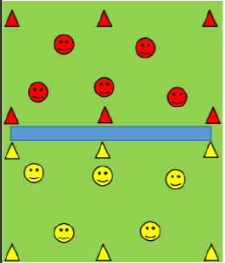
-Divide group into two even teams
Teaching Points
Bucket
Hug
Digger
Call Name
Everyone gets a go throwing the ball
-Red start with the ball. One Player from Red attempts to throw the ball ‘over the river’
-If player from opposite team (yellow) catches the ball, yellow get a point
-But if ball is dropped/ hits the ground, red team gets a point

Part One: Individual Body Catch
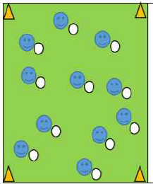
-Each Player gets a ball
Teaching Points
Catch in Bucket
Hug Ball

-Player throws up the ball in the air and body catches the ball while static
-Competition to see how many catches player can get in a row
Progression
- Player have to attempt different actions before attempting body catch
- Clap Hands once
- Clap Hands twice
- Touch Knees & Head
- Touch Toes

Part Two: Partner Body Catch
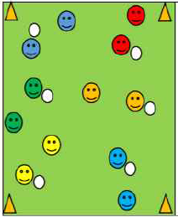
-Each player has a partner with one ball between them
Teaching Points
Bucket
Digger
Hug
Call Name

-They throw the ball to each other, using the body catch to catch the ball
-After player throws the ball they move to different area of grid
-Each pair has 3 lives, if they drop the ball they lose a life
-Once partners lose all 3 lives, they are out

Part Three: Spoil the Catchers
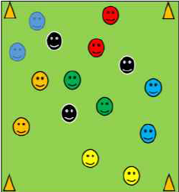
-Pairs throw & catch the ball just as before.
Teaching Points
Head Up
Keep on the Move

-3 players are spoilers (black)
-They can intercept the ball while it is in the air
-If the ball hits the ground, both players are out

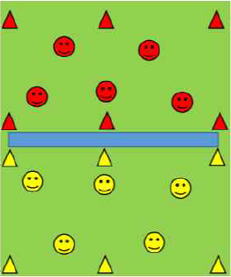
Whole Two: Over the River
-Same game as Whole One
Teaching Points
Bucket
Hug
Digger
Call Name
Everyone gets a go throwing the ball

Progression
- Use 2 balls at the same time
- Everyone must have bucket ready
- Introduce a ‘spoiler’ into each zone

