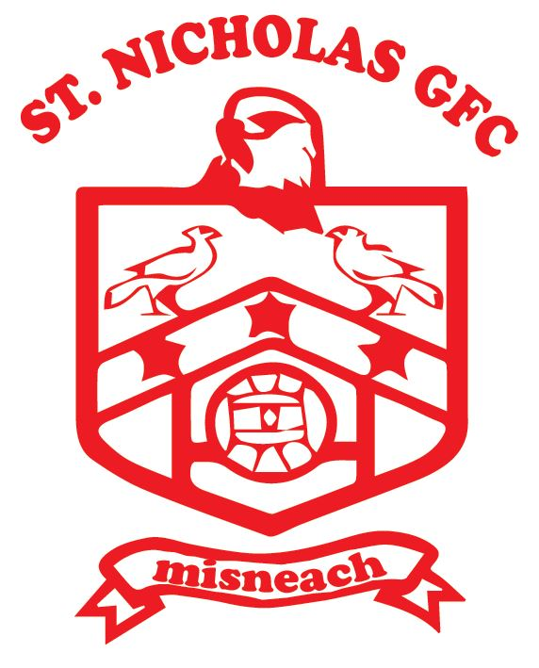

St Nicholas GFC

Player Pathway
Coaching Manual

Under 16/18
Age Group – Under 16/18
Learning to Preform

Player Characteristics:
- During this phase players begin to reach their physical peak and those slow developers
begin to catch up with their peers
- Encourage ideals of self-awareness and self-help within players
- At this stage a Functional Movement Screening (conducted by a physio) should be carried
out on each player and the results along with their Critical Success Factors(CSFs) identified
by each player in their Self-Assessment Profile should form the basis of their Personal
Development Plan (PDP).
- As a result of the above each player should have a PDP, a component of which should be
an individualised conditioning programme developed and delivered by a S&C Coach. Each
player should be committed to their programme as they will have had an input into it
through their Self-Assessment Profile.
- Advanced technical skill development Skill developed under pressure
- Understand the principles of game plays, tactics, and game sense
- Accept that the team is paramount and their role within the team structure
- Encourage positive lifestyle and build concepts of team ship and leadership
- Instil concepts of mental toughness and calmness under pressure (winning behaviours)
- Encourage flexibility and fine-tune the generic skills to play in a variety of positions
- Players should be encouraged to embrace positive life-skills i.e. time-management and to
take control of their own athletic development.

Age Group – Under 16/18
Skill Emphasis | Physical (ABC & RJT’S) | Game Specific
Game plays  How to use a sweeper  How to deal with a sweeper  Man marking  Zone marking  Kicking  Kicking for possession/diagonal ball  Kicking for scores  Cutting-in to score  Free kicks/penalties  Ball Retention  Supporting the ball player  Breaking the tackle  Getting out of traffic  Change the direction of play  Tackle  Near hand tackle  Group tackling  Frontal tackle  Checking  Blocking ball | Speed  Multi directional (runs less than 20 secs)  Quick footwork and agility  Planting the foot (the 3-step movement)  Running mechanics and techniques  Strength work to improve speed  Strength  Functional Movement (FM) assessment to establish core strength and technique  Core programme for those still not ready for weights  Individual program for those with core strength and good technique  NB: Only qualified coaches to take this training  Stamina  Small sided games  Drills incorporating the ball  Flexibility/coordination  Maintain flexibility exercises  Dynamic warm up | Intense Small-sided (3 secs)  Intense Small-sided games are extremely  beneficial for players. As well as getting involved in the game more often, players learn more quickly and make more decisions during the course of these games. And as the ball is never far away, greater concentration is required. For Example: Across the line, Total football, Break-ball & kick, 4 goal option.  15 a-side  15 a-side games are helping rehearse for  the match day scenarios. For example: Back  v Forwards, 15 v 15 (Deploying a sweeper,  defending the zones, deploying the big man,  various conditions)
up – Un
Under 16/18 – Session Plan 1
Main Body of Session
Whole Part Whole Method

12/1 Theme of Session: Keeping Possession

Warm up: Games Based Warm Up
Skill Development & Keep Possession
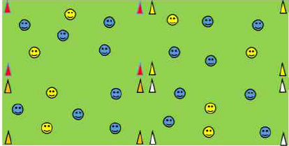
Teaching Points
Looking for space
Always on the move
Decision making
Skill Execution
Movement
Support Play
Question Players
What can they do to ensure they keep possession?
What can teammates do to ensure team keeps possession?

-Divide players into 4 even groups (depending on numbers)
Basic Skill Development (In each Grid)
Players move about grid and preform the following skills:
1. Fist Pass 2. Pick Up 3. Solo 4. High Catch 5. Roll 6. Block

Game
Keep Possession
1. 5 v 1 2. 4 v 2 3. 3 v 3

Variations
-Not allowed to pass ball back to person received ball from.
-Once you give a pass you must run to outside come before you can be active again

Whole Game One: Half Way Line Attack
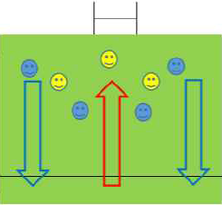
- 4A v 3B
- Team in Possession (blues) must work the ball out to the half way line before they can attack. Yellows are the defenders
Teaching Points
Communication
Question Players
How do we keep possession?
Why is it important that we keep possession?

Progression
-Progress to 4 v 4
-Fist pass Only

Part Game One: Skill Development
Combination Drill
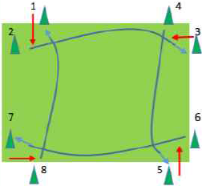
Kick Pass
Teaching Points
Head/Hands/Feet
Movement after pass
Good first touch
Timing Runs
Concentrate
Challenge Players: no balls to hit the ground
Hand Pass
-1 to 2 Hand Pass
-2 to 3 Kick pass
-3 to 4 Hand Pass
-4 to 5 Kick Pass
-5 to 6 Hand Pass
-6 to 7 Kick Pass
-7 to 8 Hand Pass
-8 to 1 Kick Pass
-Players follows their pass
-Start again

Number of balls in drill will depend on level/numbers

Whole Game Two: Half Way Line Attack
Teaching Points
Forwards run: Lateral/Diagonal
Width
Movement
Decision Making
First touch
Depth
Question Players
Why should we work the ball out wide?

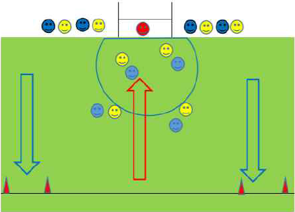

- 4 v 4 4 v 3 4 v 2
- Team in possession must work the ball out through Goals on Half way line before they can attach

Progression
- Leave two Attackers in front of goals

Whole Game Three: Space Tennis 30 Possession

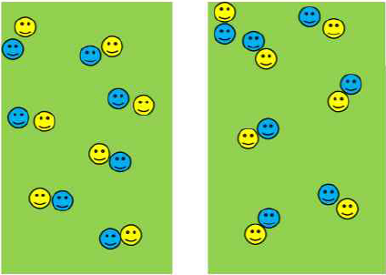
Teaching Points
Support play
Movement
Decision making
Good first touch

- 2 Teams
- Divide Pitch into two halves with half of each team members split between each half of the field
- Players are not allowed to leave their half of the field
- Game starts by kicking the ball into one section
- Whoever wins possession must try and keep the ball for 30 seconds or 5 passes before it is kicked over into the other half
- Teams are trying to kick pass the ball to a teammate on the other side

Progression
-Score for every successful pass. (Hand Pass = 1 point, Kick Pass = 3 points)
-Team with the most points at the end wins/ Winning after 5/7/10 minutes
-Deduct points for every incomplete fist/kick pass
Uneven teams

Under 16/18 – Session Plan 2
1 Theme of Session: High Catch

Warm up: General Mobilisation
Focus on Jumping (High Catch)
Teaching Points
Jumping
Small steps
Plant & drive
Jump the arc
Land running
Change jump off foot
High Catch
Timing
Drive knee
Extend arms above head
Eyes on ball
Spread fingers
Pull ball into chest

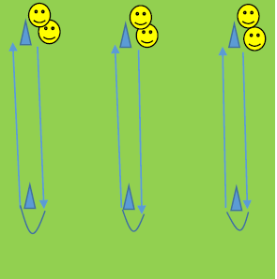
General Movements
High Knees/ Heels Flicks/ Side to Side

Jumping
- Single leg hop
- Skipping (focus on arms)
- Straight bounding
- Lateral bounding

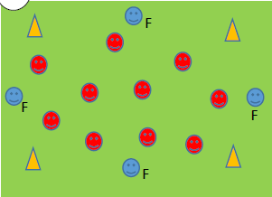
Skill Development: High Catching Game
- Players move around square in different directions
- Four feeders on the outside (blue)
- Feeders throw the ball up in the air for the inside players to high catch the ball
- Ball returned to the feeder once caught
Main Body of Session
Whole Part Whole Method
Whole Game One: Midfield Build Up
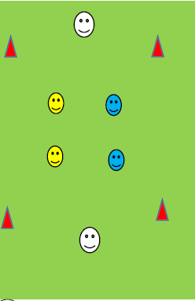
-2 sets of midfielders contest high balls played into middle zone by 2 feeders (white)
Teaching Points
Communication
Link skill to our game
Question Players
Why do we need to perform this skill

-All players must attempt to catch the ball
-Clean catch = 2 points
-Work ball back to feeder

Progression
-Midfielders work together: 1 performs High Catch, other anticipates breaking ball
- 2 Points for a catch, 1 Point for breaking ball won
Part Game One: Coach Feeds & Catch
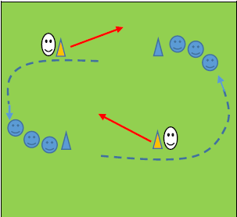
- Throw
Teaching Points
Timing
Plant foot (feet)
Drive Knee
Extend Arms
Eyes on ball
Spread Fingers
Land running

--- > Run
-Coach (white) feeds ball to attacker for him to perform the High Catch
-Attacker passes back to Feeder & joins the second group

-Set up 2/3 of these

Part Game Two: Two Up & Catch
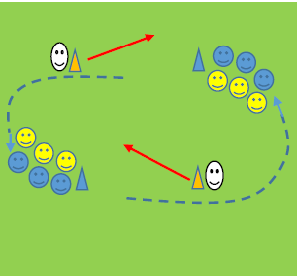
- Throw
Teaching Points
Question Players
How do I make room to catch the ball?
Use hips to disrupt partner

--- > Run
-Same drill as above only 2 players contest for the ball
-Players must attempt to high catch the ball

Part Game Three: High Catch & Pass
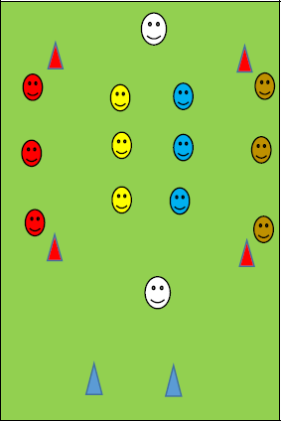
- 4 teams of 3/4/5
- Coach (White) kicks ball between groups in square
Teaching Points
Timing
Drive Knee
Extend Arms
Eyes on ball
Spared fingers
Land running
Push off after catching ball
Support Play
- Players must attempt to Hight catch the ball
- 2 points for high catch
- Team who win possession must work ball back to feeder
Progression
- Feeder moves around outside of square
- After two passes team attempt to score a goal (blue cones)

Whole Game Two: High Catch & Pass
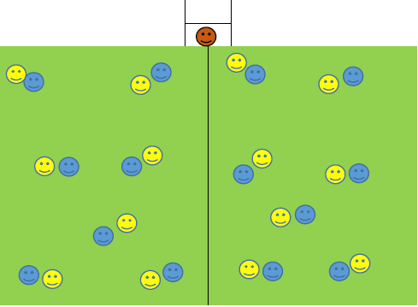
-Divide Pitch into two halves with half of each team members split between each half of the field
-Goalkeepers kick out the ball to one side of the field
-Both teams try to High catch the ball (not allowed to break ball)
Teaching Points
Call Name
Read Ball
Time Runs
Demand Ball
-If your team catches the ball they get 2 points. 1 point for body catch
-Must get 3 passes before kicking ball into other half of the field 50/50. Ball must be caught
- 2 points if your team catches the ball
- 3 passes before team can shoot
-Coach keeps score, highest score after 3/5/7/ minutes
-Goalkeeper rotates sides to which he kicks out the ball

Progression (Skill Development Games)
-Award points for successful fist pass (cheat), Kick pass (chest, bounce) and first touch
-If ball is dropped or bad pass, team lose point
Under 16/18 – Session Plan 3
Theme of Session: Tackling

Warm up
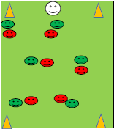
Chasing Game: Tail Tag
Tail Tag: In partners, one attacker,
one defender. The attacker has a bib at
Teaching Points
Attacker
Head UP
Find Space
Quick Feet
Change Direction
High Catch
Defender
Shadow
Touch Tight
Near Hand
Quick Hands

back of their shorts and defender has
to try and get the bib off the attacker.
(30 seconds on/ off)
Progression
1. Once a player loses their bib he
gets one off a coach.
2. Put bib to Right/ left side of
shorts so defender has to use near
hand to get bib. Players can only use left/ right hand only.

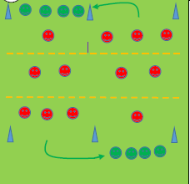
Pass the Guard: Frontal / Shadowing
- Attackers (green) try to get through each zone without getting tagged by defender (red).
- Tacklers must try & tag each player ‘on chest’ with open hand
- Reds to stay in designated zone.
- Rotate roles every 2/ 3 minutes.
- Introduce ball where attackers carry though grid.

Main Body of Session
Whole Part Whole Method
Whole Game One: One to One
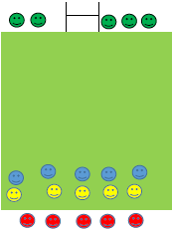
- Divide into 4 groups.
Defender
Attacker
Feeder 1
Feeder 2
- Feeder 1 feeds the ball to attacker (allowed to win ball uncontested).
Teaching Points
Question Players
How many different types of tackles are there?
Touch Tight
Boxer Stance
Quick Hands
Near hand
Balls of feet

- Takes on defender one on one & can score points only
- Feeder 2 gets ball & feeds ball to attacker who takes on defender and tries to work the ball back to Feeder 1.
- Rotate roles every minute.

Part Game One: Tackle Alley – Frontal Tackle
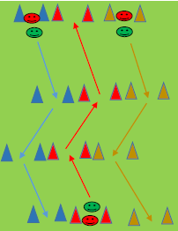
- In Partners
One Attacker/ One Defender
-Both players are facing each other
-The Defender (Green) places their hands
behind their back and will move backwards using his footwork to stop the attacker (Red) from getting by him.
Progression
1. Use hands & feet
2. Introduce ball attacking player goes
slow at the start.

Part Game Two: Tackle Alley – Near Hand Tackle
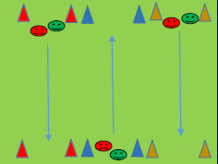
Teaching Points
Timing
Step Across
Shoulder to Shoulder
Near Hand
Stop Ball to you advantage
Question Players
What Skills would you need to perform the NHT?
Question Players
Do you play from front/side/behind?
Why?
Touch Tight
Quick Hands
Boxer Stance
NHT

- Red has ball and
slowly solos the ball in a straight line until
end of alley
- Green tracks run and tries to execute the NHT before A reaches end of alley.
- Swap Roles
- Walk – Jog – Run –
Sprint – Game Pace

Whole Game Two: One to One Part Two
- Divide into 4 groups.
Defender
Attacker
Feeder 1
Feeder 2
- Feeder 1 feeds the ball to
attacker (Defender allowed
to contest).
- Attackers takes on defender one on one
- Has to pass to another feeder, who returns pass before attacker can score (goals only)
- Feeder 2 gets ball & feeds
back to attacker who has to work it back to original Feeder 1.

Whole Game Three: Six of the Best
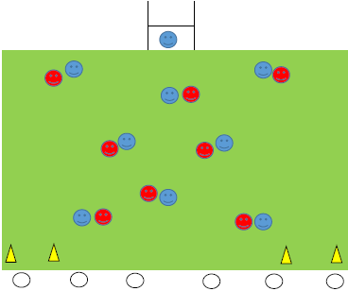
- Attackers (Blue) get 6 balls and have to try and work a score.
- Their aim is to get as many scores as possible.
- Defenders (Red) implement skills they have worked on throughout session to prevent a score.
Teaching Points
Question Players
Do they know any good defenders?
What makes them good tacklers?

- If defenders win turnover they get a score.
Progression
- Uneven teams, give advantage to attacking team
- Defender wins turnover & work it out through cones (yellow) on the half way line.
- Different method used for scoring each time (ie. If first score kicked point with right foot, nest score has to be either fisted point, kicked point with left foot or goal with either foot.
- Different player to score each time.

Under 16/18 – Session Plan 4
Theme of Session: Attacking Play

Warm up
GAA-15-Warm-Up

See attached Print outs

Combination Drill
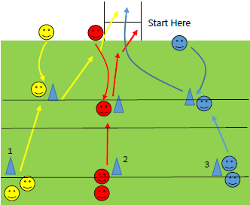
Teaching Points
Good 1st touch
Ball to hand
Fist Pass
Strike through arm backwards & forwards
Shooting
Pick spot (behind goals)
Follow through
Head down
Sweet Spot

- 1. Solo, Fist Pass and Fist Over the Bar.
- 2. Solo, Fist Pass, and shoot for Goal.
- 3. Solo, Kick Pass and shoot for Point.
- Player who passes ball puts pressure on shooter.
- Dynamic Stretches throughout

Main Body of Session
Whole Part Whole Method
Whole Game One: Shooting 4 v 3
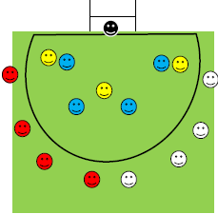
- Divide players into teams of four.
Teaching Points
Question Players
How do you get free from defender?
Movement (find space)
Zig/Zag movement
Taking on Man
B.A.B
Protect the ball

Question Players
How do you take on a defender?
Side Step
Roll
B.A.D
Dummy

- Mark perimeter around goals as
shown (size depends on age/ ability)
- Goals & Fisted
Points only.
- 8 Balls (1 ball each for outside players).
- One ball at a time (on coach’s whistle),
player passes ball to attacking team to try and work a score.
Part Game One: Tackle Alley 1v1/2v2
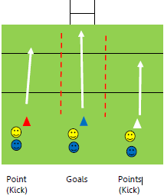
- Players divide into 3 groups as shown.
- One partner is the forward (Blue) and the other is the
defender (Yellow).
- The forward has a ball and must take on the defender and try and score (Red;
Fisted Point, Blue;
Goal, White; Kicked Point)
Progression
- Make it a 2 v 2

Whole Game Two: Shooting 4 v 3

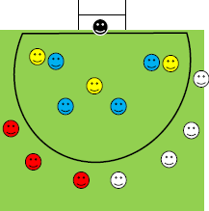

- Same layout as Game One.
Teaching Points
Pass & Move
Find a man with pass
Protect ball (B.A.D) if taking a man on

- 3 passes before team can shoot
- Goals and fisted points only

Progression
- All players must touch the ball & take on marker before team can shoot.
- All type of scores count.

Whole Game Three: Circle Goal

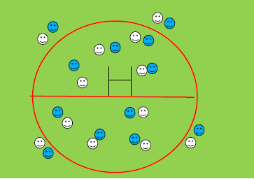

- Two Teams with goals placed in centre of field
- Coach throws ball up
Teaching Points
Question Players
How can you keep possession?
How can we win back the ball?
How can we work a score?

- Players must stay inside designated area.
- Ball can be passed from zone to zone by foot or hand.
- The game is continuous, it doesn’t stop after a score
- Players on other side attempt to win possession after a score.

Progression
- Extra point for scoring Outside Circle
- Nominate players to stay outside area.
- Must pass to them before a team can score.
- First team to 5 scores.
- Have to use a different method of scoring each time.
- Different player has to score each time.

Under 16/18 – Session Plan 5

Theme of Session: Development (Star Format)

Warm up
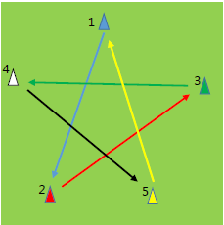
Star Format: Dynamic Movements
- Players jog through grid performing
different movements & dynamic stretches.
Teaching Points
Follow Ball
Head Up
Time Run

Progression
Introduce ball
Teaching Points
Punt Kick
Laces
Head Down
Follow Through
Judge weight of pass
Kick & Follow

- Solo & Fist Pass
- Solo and Pick Up
Solo & High Catch
- Solo & (First Touch)
Bounce ball.
- Size of area depends on your numbers
Star Format: Two (Truck & Trailer)- Handling
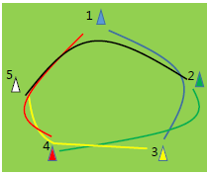
1 Passes to 2, 2 returns it to 1
Teaching Points
Ball to Hand
Target area
Support Pass
Concentrate
Good First Touch

who continues with 1. 1 passes
to 3 (1 joins back of 3 group),
who then passes to 2 who then
passes to 4 (2 joins 4 group) to
passes to 3. 3 passes to 5 (who
joins 5 group) who then passes
back to 4. 4 passes to 1 (who
then joins 1 group). This is
continually repeated.

- 3/ 4 balls.
Star Format: Three (Star Kick – Kick Pass)
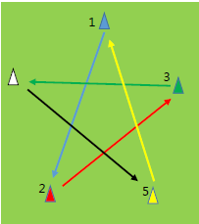
- Players kick pass in the
following order.
- Player follows their
pass.

Progression
- Once player receives a
kick pass, they fist pass
ball to next player in line,
who times their run off
the shoulder.
- Cones 30m apart.
Main Body of Session
Whole Part Whole Method
Star Method 1v1 / 2v2 Attack and Defend One
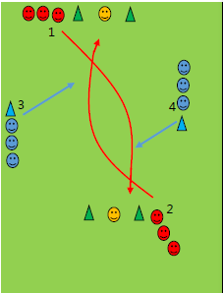
- Attacker (red)
Teaching Points
Defender
Near Hand Tackle
Push to wings
Frontal Tackle
Attackers
B.A.D
Roll/Side Step
Work the keeper

- Defenders (blue)
- Attacker at 1, attacks goals on opposite side. Defender at 3 attempts to stop attacker.
- Once the ball goes dead, attacker & defender and 2 & 4 repeat exercise going other way.
- Rotate attackers & defenders.
- Goals Only
Progression
- 2 attackers v 2
defenders
Star Format: Attack Defend Two (3 v 3)
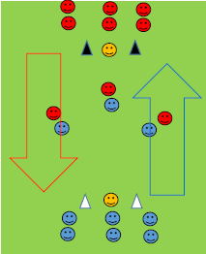
- Red team have the
Teaching Points
Move the ball through Hands
Intensity
Good first touch
Front & NHT
Finish
Low & Work the Keeper
Shooting
Pick a spot behind the goal
Head Down
Follow Through
Target
How many scores in 2 minutes

ball and attack white
goals.
- Blue team are the
defenders.
- Once ball goes dead,
the red team that
where attackers
become the defenders
and the next set of
blue attack the black
goals.
- Goals only

Star Format: Combination Drill (Shooting)

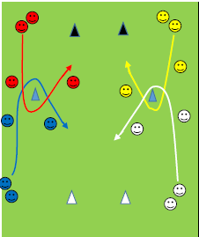
- Divide into 4
groups,
- From each corner player takes it in turn to solo ball
out to blue cone.
- They turn and take a shot for a point
- Other players at cone retrieve the ball and repeats
drill.
- How many scores
can each group get

Progression
- Add in defenders
(token pressure)

Star Format: Game One 4 v 4 Half Way Line Attack
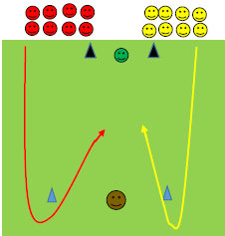
- 4 v 4 in each half
of the field.
Teaching Points
Move the ball through Hands
Intensity
Good first touch
Front & NHT
Finish
Low & Work the Keeper
Shooting
Pick a spot behind the goal
Head Down
Follow Through
Target
How many scores in 2 minutes

- Players sprint
out to middle
cone.
- Once they go
around cone and
enter playing area,
coach (gold)
throws ball in.
- Whoever wins
ball attacks & tries
to score a goal.

Star Format: Progression
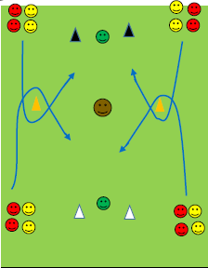
- Coach (gold)
throws ball up
1. Whoever wins
ball, attacks any
goal.
2. Team must get
3 passes before
scoring.

