

**St Nicholas GFC**

**Player Pathway**

**Coaching Manual**

**Under 10/11**

|  |
| --- |
| **Age Group – Under 10/11** |

**Learning to use the ball well**

**Player Characteristics:**

* Players will compete with greater intensity against each other.
* At this age players will now try to win the game not only by scoring but also by attempting to deny the opposition the opportunity to score.
* They will begin to understand the need to change the direction of a run or a pass to be more effective and they will begin to grasp the idea that a player may need support from behind and to the side as well as in front.
* Coaches should continue to run small-sided games and condition them to solve problems.
* During training, these players must always feel part of the session. Coaches must be ready to pay as much attention to them as to other established players and always work to improve their skills *[e.g. one-to-one coaching may be needed].*
* Coaches must be quick to address the problem of one or two players dominating play and preventing others from developing their skills during games.
* Many players at this age fail to recognise the need to attack the ball and prefer to wait for the ball. If this is allowed to persist, that player will find it increasingly difficult to change his/her instincts.
* Training needs to be moderately increased at this stage.
* Players are now ready to develop general strength through their own body weight and core exercises.

|  |
| --- |
| **Age Group – Under 10/11** |

|  |  |  |
| --- | --- | --- |
| **Skill Emphasis** | **Physical (ABC & RJT’S)** | **Game Specific** |
| **Handling**  High catch  Hand passing (both hands)  **Kicking**  Punt kick (left and right)  Punt kick (outside of foot)  Crouch lift (moving ball)  Toe lift  Hook kick (left and right)  **Travelling**  Solo run (left and right)  Low bounce  Dummy solo  **Tackle**  Near hand tackle  Shadowing  Shouldering  Frontal tackle  Block down | **Speed**  Development of speed (runs less than 6 secs)  *For Example:* Quickness, Change of direction and Reaction sprints.  **Strength**  Introduce core strength *For Example*: Twist with Partner  Own body strength exercises.  *For Example:* Pull ups, Press ups etc…  Introduce plyometric training  *For Example:* Bounding and hopping  **Stamina**  Endurance related activities  *For Example:* Relay running  Small sided games and ball drills  Circuit training with the ball  **Flexibility/Coordination**  Introduce dynamic stretching and mobility exercises  Warm up and cool down concept | **Court games**  Divided court games require players to pass the ball over an obstacle like a net or zone to a receiver. The use of other skills essential for team work such as communication, anticipation and spatial awareness become more apparent. *For Example:* Over the river, Hit the corners  **Field games**  These are games which require one team to act as the kickers and the opposition become retrievers. The retrievers team tries to limit the runs or scores by the kicking team and at the same time try to get the opposition players out. For Example: Crazy kicks, Batter bonanza  **Part invasion**  These games require players to complete a task with limited or direct opposition. Part-invasion games allow players to develop positional sense and decision making with limited pressure from the opposition*. For Example*: 4v1 (Game), Pass  and attack  **Full invasion**  The core objective in invasion games is to move  into an opponent’s territory to score. *For Example*: 4v4 (Split ends), 5v5 |

|  |
| --- |
| **Age Group – Under 10/11** |

**Key considerations at this level:**

* Training sessions should be enjoyable and inclusive of all players.
* Groups and teams should be divided evenly in terms of ability, age and gender.
* Demonstrate the skills and drills slowly to players.
* Keep drills short and varied so that players remain interested throughout the training session.
* Players should use **both hands and both feet** when learning new skills and playing games.
* Coaches should encourage players, acknowledge their effort and praise them regularly.
* Give time at the end of a session to reflect with the players on the quality of the training session.
* Encourage players to practice their skills at home.
* The sample sessions provided focus on three skills in each session. Each skill develops further as sessions progress. Coaches are encouraged to build their own sessions, varying the skills focused upon and addressing the needs of the players.
* Additional activities are included to show how each skill can be developed further.

**Duration of training session: 75 minutes**

**Equipment/Resource List:**

* Each player should have a bib (different colours for opposing teams).
* 1 ‘Quick touch’ football between two players.
* Coach/player ratio: 1:6.
* 1 set of training cones.
* 1 set of training poles.
* 1 set of water bottles.
* Sets of goal posts (10ftx6ft).
* Whistles for coaches/referees for games.
* 9-a-side games.
* Game duration– 4 quarters of 8 mins approx.
* Go Games rules apply.
* First Aid bag.

**Pitch Dimensions:**

* 65 meters x 40 meters
* Three zones

|  |
| --- |
| **Under 10/11 – Sample Sessions** |

**Sample Session 1**

**Key Skills – Reach Catch, Block Down & Hook Kick**

**Session Structure Duration**

Warm up 10 mins

Introduce the focus of the session 5 mins

Partner Catch 10 mins

Partner Block 10 mins

Partner Kick 10 mins

Game – 9v9 25 mins

Session Review and Conclusion 5 mins

**Sample Session 2**

**Key Skills – Reach Catch, Block Down & Hook Kick**

**Session Structure Duration**

Warm up 10 mins

Introduce the focus of the session 5 mins

Pressure Catch 10 mins

Move and Block 10 mins

Around the Square (Hook Kick Drill) 10 mins

Game – 9v9 25 mins

Session Review and Conclusion 5 mins

|  |
| --- |
| **Under 10/11 – Sample Sessions** |

**Sample Session 3**

**Key Skills – Reach Catch, Block Down & Hook Kick**

**Session Structure Duration**

Warm up 10 mins

Introduce the focus of the session 5 mins

Cross Catch 10 mins

Zig-Zag Block 10 mins

Kick and Move 10 mins

Game – 9v9 25 mins

Session Review and Conclusion 5 mins

**Sample Session 4**

**Key Skills – Solo, Crouch Lift & Checking**

**Session Structure Duration**

Warm up 10 mins

Introduce the focus of the session 5 mins

Stationary Top Tap 10 mins

Lift and Drop 10 mins

Hang on (Checking Drill) 10 mins

Game – 9v9 25 mins

Session Review and Conclusion 5 mins

|  |
| --- |
| **Under 10/11 – Sample Sessions** |

**Sample Session 5**

**Key Skills – Solo, Crouch Lift & Checking**

**Session Structure Duration**

Warm up 10 mins

Introduce the focus of the session 5 mins

Toe Tap, Turn and Pass 10 mins

Bridge Ball (Crouch Lift Drill) 10 mins

Zig-Zag Check 10 mins

Game – 9v9 25 mins

Session Review and Conclusion 5 mins

**Sample Session 6**

**Key Skills – Solo, Crouch Lift & Checking**

**Session Structure Duration**

Warm up 10 mins

Introduce the focus of the session 5 mins

Crazy Solo 10 mins

Opposed Lift (Crouch Lift Drill) 10 mins

Zig-Zag Check with Ball 10 mins

Game – 9v9 25 mins

Session Review and Conclusion 5 mins

|  |
| --- |
| **Under 10/11 – Sample Sessions** |

**Sample Session 7**

**Key Skills – Fist Pass & Side to Side Charge**

**Session Structure Duration**

Warm up 10 mins

Introduce the focus of the session 5 mins

Stationary Pass 10 mins

Imitation Charge 10 mins

Pressure Pass (Fist Pass 2nd Drill) 10 mins

Game – 9v9 25 mins

Session Review and Conclusion 5 mins

**Sample Session 8**

**Key Skills – Fist Pass & Side to Side Charge**

**Session Structure Duration**

Warm up 10 mins

Introduce the focus of the session 5 mins

Move and Pass 10 mins

Tackle Bag Charge 10 mins

Charge and Lift (Side to Side Charge 2nd Drill) 10 mins

Game – 9v9 25 mins

Session Review and Conclusion 5 mins

|  |
| --- |
| **Under 10/11 – Reach Catch** |

**The skills outlined here have been identified as appropriate for players under the age of 10. Remember that some players progress quicker than others and may have mastered these skills. In this case progress to the skills outlined in the U-12 section of this resource.**

**Reach Catch**

The Reach Catch in Football is a technique used to catch the ball when it approaches at or above head height. It forms the basic element of the overhead catch.

**Block Down**

The Block Down is a tackling skill used to prevent an opponent shooting for a score or passing to another player. In scoring situations, the Block Down is an effective and dramatic defensive skill.

**Hook Kick**

The Hook Kick is a kicking technique used in Gaelic Football. It is predominantly used to shoot for points but is also used to pass to a team mate at an angle to the player in possession.

**Solo**

The Solo or ‘toe tap’ in Gaelic Football is a technique used to play the ball in order to keep possession without fouling. It is used to carry possession to a better position or to evade an opponent. A solo run may incorporate a sequence of alternating bounces and toe taps, or just be a series of toe taps.

**Crouch Lift**

The Crouch Lift is a basic skill in Gaelic Football used to lift the ball from the ground into the hands.

**Checking**

Checking (shadowing) in Gaelic Football is a tackling skill used to force an opponent away from goal, into a poor position or onto their weaker side. Performed intelligently it is a very effective form of tackle. It is also known as jockeying.

**Fist Pass**

The Fist Pass is a variation of the handpass technique in Gaelic Football used to pass the ball over a short distance. The technique involves supporting the ball in one hand and striking it with the closed fist of the free hand. A fisted pass will travel a greater distance than an open-handed handpass. Remember a fisted pass may be used to score a point but an open-handed pass may not.

**Side to Side Charge**

In addition to mastering the non-contact skills, players must learn the contact skills necessary to participate in game situations. The Side to Side Charge is the basic contact skill required by football players. It may be used when the opponent is in possession of the ball, when they are playing the ball or when both players are moving in the direction of the ball to play it.

|  |
| --- |
| **Under 10/11 – Reach Catch** |

**Key Teaching Points**

* With head up, keep eyes on the Ball
* As the ball approaches, extend the arms towards the ball and spread the fingers

Keep the thumbs behind the ball forming a ‘W’ shape with the index fingers

* When the ball approaches from above, catch it slightly in front of the head at its highest point
* On receiving the ball, secure the ball into the chest with both hands

**Common Errors**

* Not extending the arms fully: this may result in the ball being intercepted in a game situation as an opponent reaches and catches the ball first
* To correct, extend the arms fully towards the ball and spread the fingers to receive the ball
* Catching the ball behind the head
* To correct, catch the ball slightly in front of the head, at its highest point

|  |
| --- |
| **Under 10/11 – Reach Catch** |

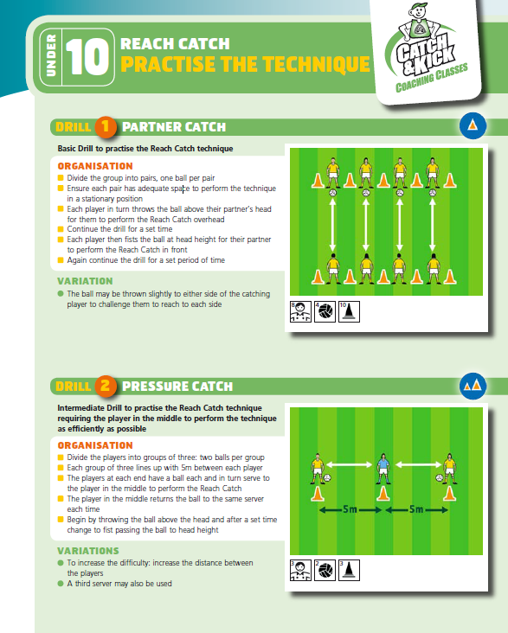**Practice the Technique**

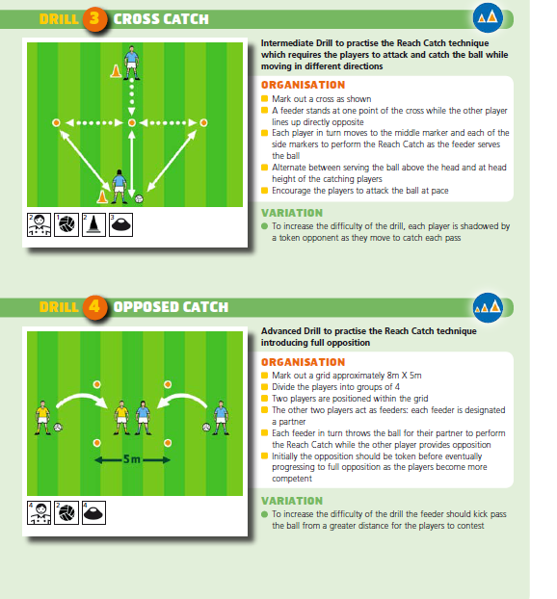

|  |
| --- |
| **Under 10/11 – Reach Catch** |

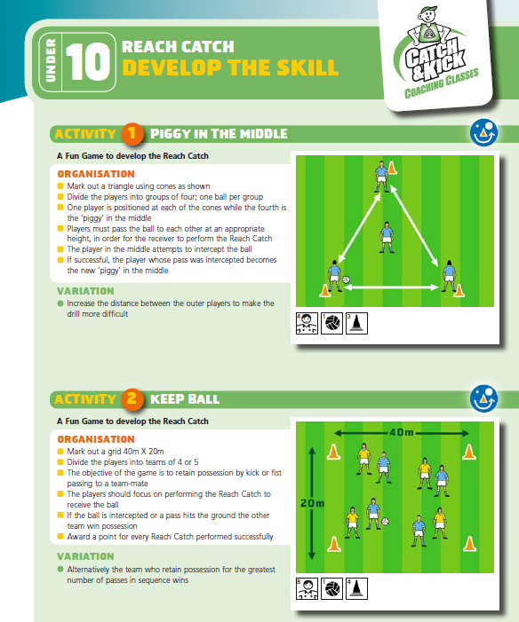**Develop the Skill**

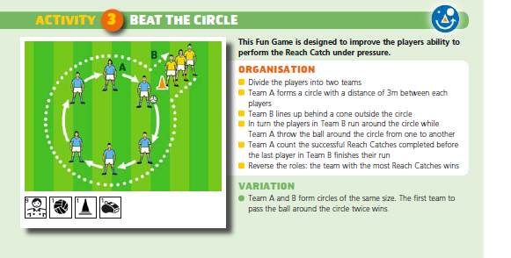

|  |
| --- |
| **Under 10/11 – Block Down** |

**Key Teaching Points**

* Stand close to the opponent in the Check position
* As the opponent prepares to play the ball, reach forward with the arms outstretched and hands close together

Keep your eyes on the ball

* Block the ball at the point of contact with the boot

Move to regain possession ahead of the opponent

**Common Errors**

* Shying away from contact
* To correct, introduce the player to the contact situation in a slow and controlled manner
* Missing the ball as it passes between the outstretched arms
* To correct, keep the hands close together, moving confidently to block the ball at the point of contact with the boot
* Closing the eyes when attempting to perform the Block Down: this may result in the player missing the block as they fail to react to the direction of the kick
* To correct, keep the eyes open at all times, focusing on the ball at the point of contact

|  |
| --- |
| **Under 10/11 – Block Down** |

**Practice the Technique**

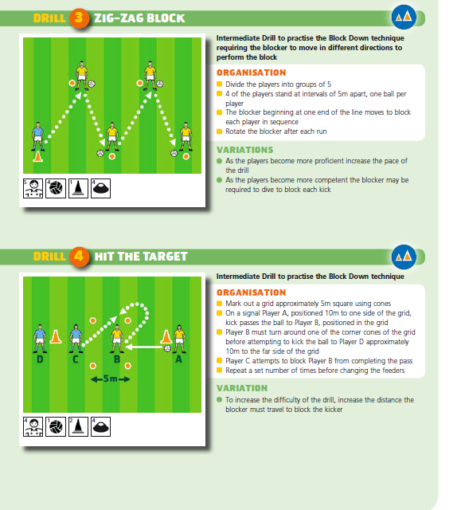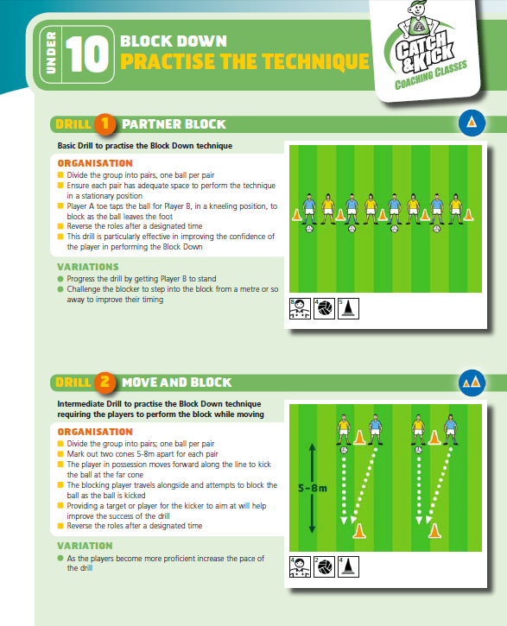

|  |
| --- |
| **Under 10/11 – Block Down** |

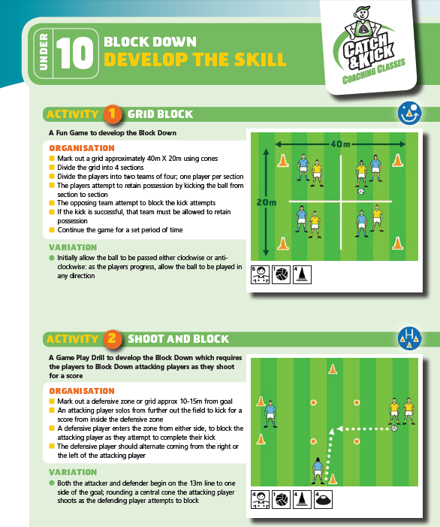**Develop the Skill**

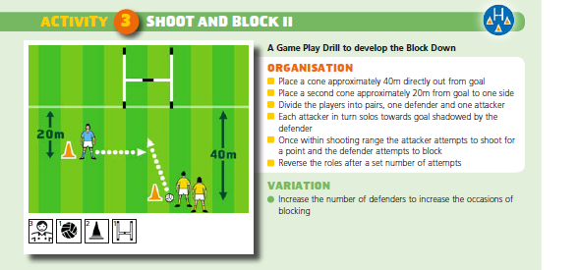

|  |
| --- |
| **Under 10/11 – Hook Kick** |

**Key Teaching Points**

* Hold the ball firmly with both hands

Point the shoulder towards the target

* Release the ball into the hand at the kicking side and extend the opposite arm away from the body to aid balance
* Step forward with the non-kicking foot

Extend the wrist and drop the ball onto the kicking foot

* Kick the ball with the inside of the foot
* Follow through with the kicking leg across the body in the direction of the target, with the toe pointing upwards

**Common Errors**

* Not pointing the shoulder towards the target: this may lead to inaccuracy in the pass or shot
* To correct, point the shoulder to the target before taking the kick
* Dropping the ball from the opposite hand to the kicking foot: this can lead to the player over hooking the ball and misdirecting the pass or shot
* To correct, drop the ball from the hand at the kicking side and extend the opposite arm away from the body to aid balance
* Lifting the head too early: this can lead to mis-kicking the ball and sending the ball in the wrong direction
* To correct, continue to keep the head down, focusing on the point of impact until the follow through is complete

|  |
| --- |
| **Under 10/11 – Hook Kick** |

**Practice the Technique**

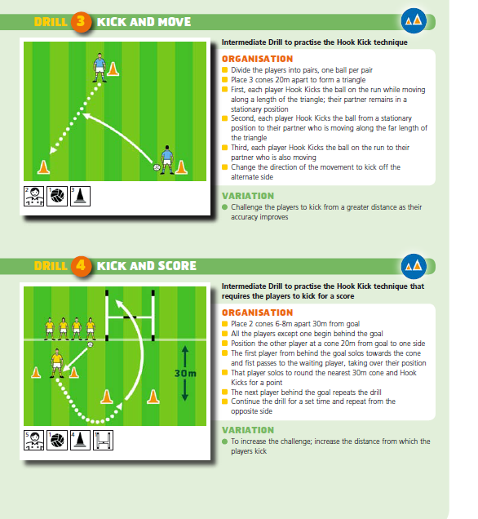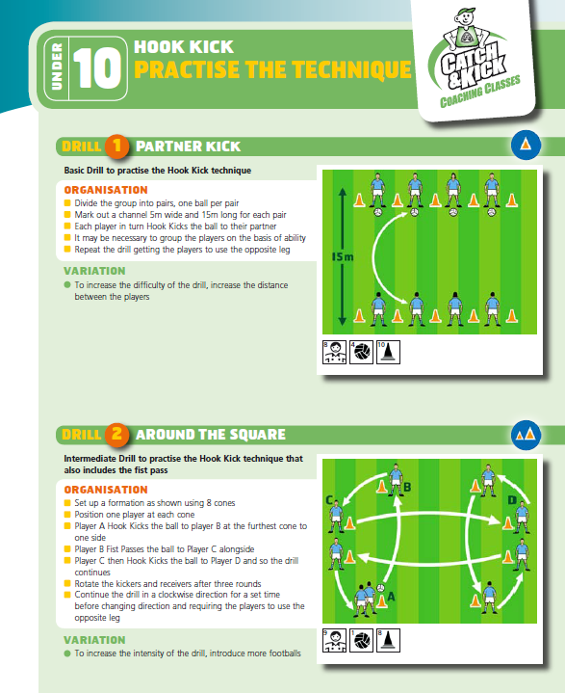

|  |
| --- |
| **Under 10/11 – Hook Kick** |

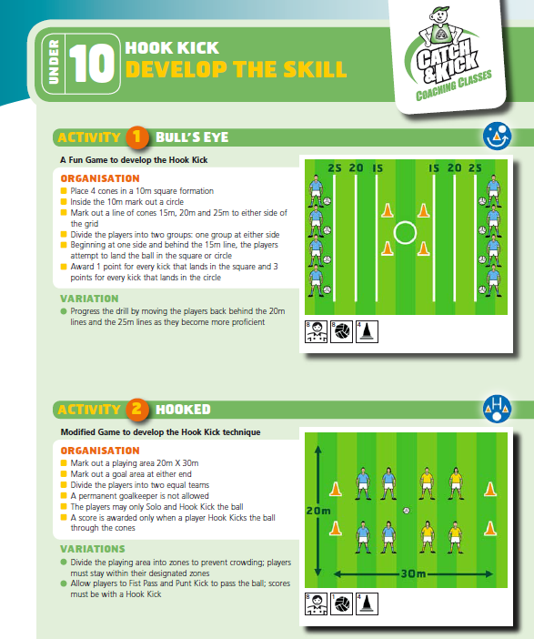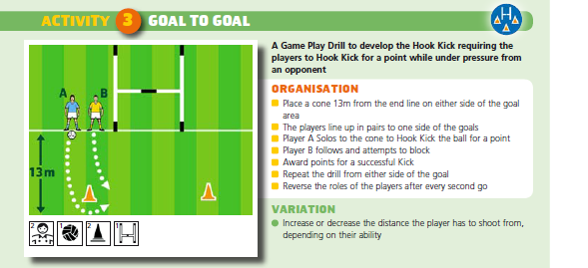**Develop the Skill**

|  |
| --- |
| **Under 10/11 – Solo** |

**Key Teaching Points**

* Hold the ball firmly with both hands

Keep the torso upright

* Release the ball into the hand at the kicking side

Head down, eyes on the ball

* Step forward with the non-kicking foot

Extend the wrist and drop the ball onto the kicking foot

* When the foot impacts the ball, flick the toe upwards towards the body

Straighten the leg

* Extend the arms forward to catch the ball

**Common Errors**

* Dropping the ball with both hands or dropping the ball to the foot with the wrong hand: this may lead to difficulty keeping control of the ball, particularly, when attempting to Solo at speed
* To correct, drop the ball toward the kicking leg with the hand at the same side
* Throwing the ball to the kicking foot
* To correct, the ball is dropped and not thrown from the release hand
* Not using a straight leg to flick the ball upwards towards the body: this may result in the player failing to control the ball
* To correct, kick the ball at the end of the stride, flicking the toe upwards to bring the ball back into the body
* Soloing the ball too high
* To correct, ensure the ball is cushioned back by flicking the toe upward on impact

|  |
| --- |
| **Under 10/11 – Solo** |

**Practice the Technique**

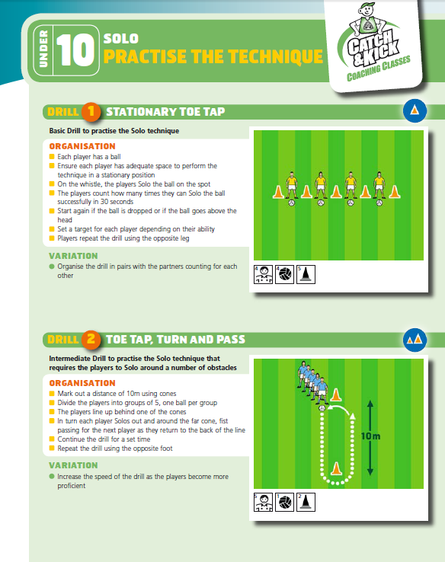

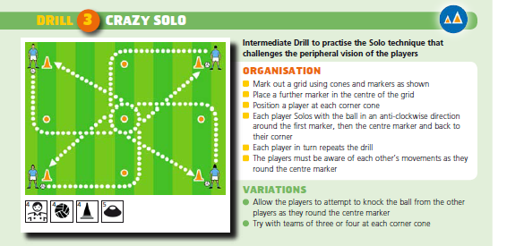

|  |
| --- |
| **Under 10/11 – Solo** |

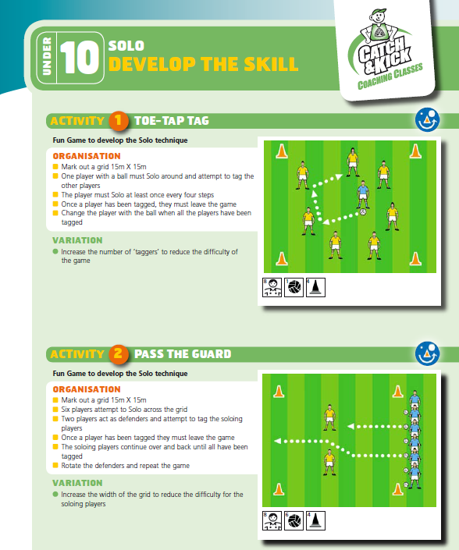**Develop the Skill**

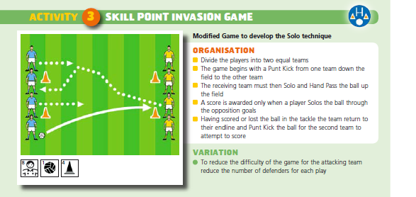

|  |
| --- |
| **Under 10/11 – Crouch Lift** |

**Key Teaching Points**

* Move to the ball

Bend the back and knees, placing the supporting foot alongside

and a little ahead of the ball

* Place the hands in front of the ball in a cupped position with the fingers spread
* Bring the lifting leg forward, scooping the ball forward into the cupped hands
* Draw the ball into the body to secure possession

**Common Errors**

* Not crouching to lift the ball: this may result in the player kicking the ball forward rather than lifting it into the hands
* To correct, bend the back and knees to Crouch Lift the ball
* Not placing the hands in front of the ball or leaving too much of a gap between the hands: this may result in the ball slipping through the player’s hands and failing to secure possession
* To correct, place the hands in front of the ball in a cupped position with the fingers spread
* Touching the ball on the ground: this may result in a free being awarded against the player
* To correct, bring the lifting leg forward to scoop the ball into the cupped hands
* Not planting the support foot beside the ball: this may leave the player off balance and stumbling over or result in the ball being kicked ahead instead of lifted into the hands
* To correct, judge the stride length as you approach the ball and plant the support foot to the side of the ball as the lifting foot comes through to scoop the ball into the hands

|  |
| --- |
| **Under 10/11 – Crouch Lift** |

**Practice the Technique**

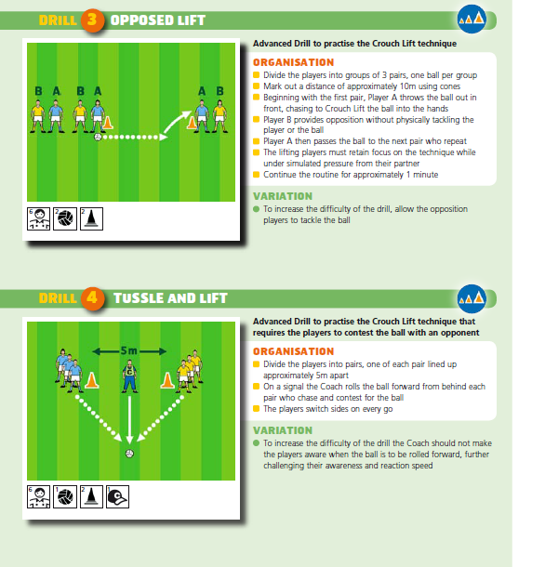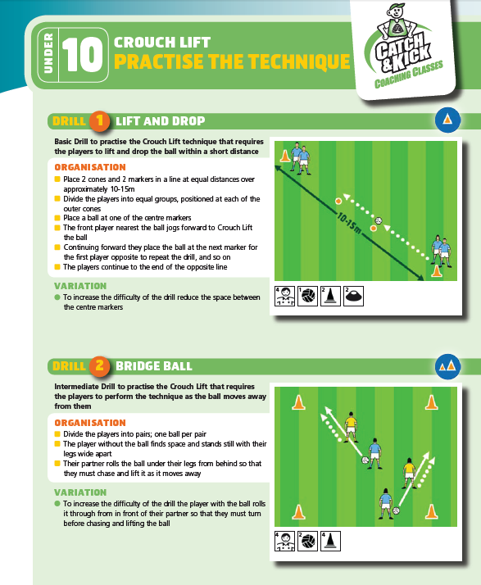

|  |
| --- |
| **Under 10/11 – Crouch Lift** |

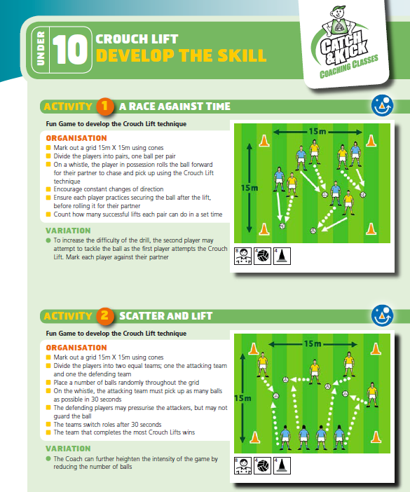**Develop the Skill**

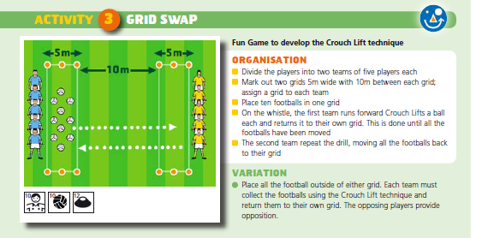

|  |
| --- |
| **Under 10/11 – Checking** |

**Key Teaching Points**

* Position the body between the opponent and the goal.

Keep the feet wide and bend the knees

* Lean slightly forward
* Extend the arms to either side with fingers spread
* Use short steps to shadow the opponent and avoid crossing the legs
* Keep one foot slightly ahead of the other to aid stability and enable a quick change of direction
* Once the ball is in sight, or as the ball is being played, attempt to intercept it with an open hand

**Common Errors**

* Poor positioning: this may result in the player failing to contain the opponent or being caught off balance
* To correct, take up position between the opponent and goals; keep the feet wide and bend the knees, leaning slightly forward
* Reaching in and losing balance
* To correct, keep the knees bent with one foot slightly forward for stability and quick movement
* Crossing the legs: this may result in the player being unable to change direction with the opponent
* To correct, keep the feet wide and use short steps to shadow opponent

|  |
| --- |
| **Under 10/11 – Checking** |

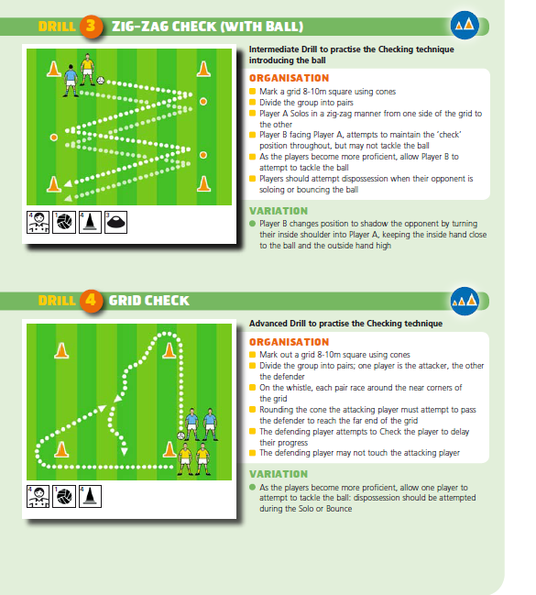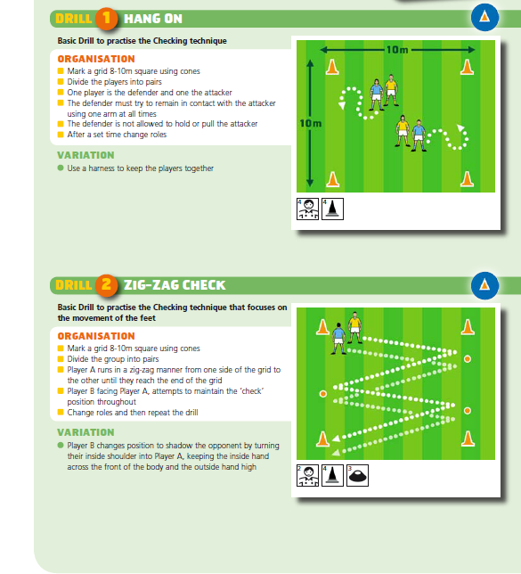**Practice the Technique**

|  |
| --- |
| **Under 10/11 – Checking** |

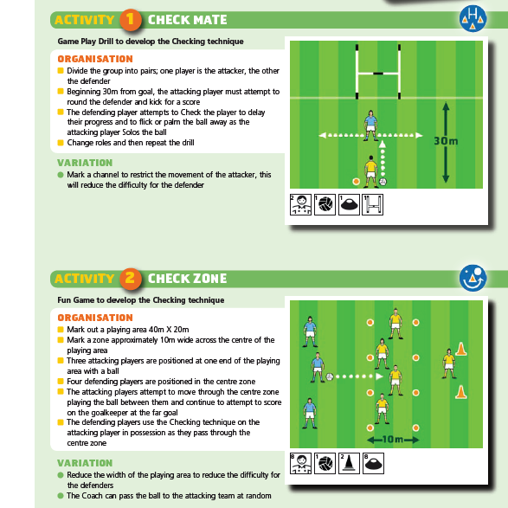**Develop the Skill**

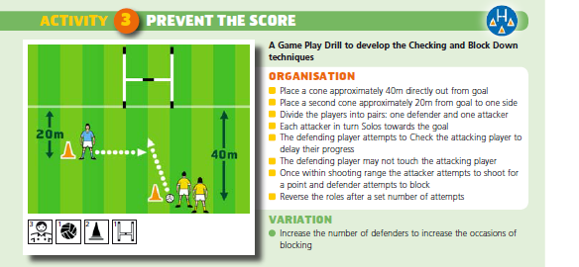

|  |
| --- |
| **Under 10/11 – Fist Pass** |

**Key Teaching Points**

* Support the ball in the palm of one hand in front of the body

Face the target

* Swing back and extend the striking hand

Keep eyes on the ball

* Lean forward and strike through the middle of the ball with the fist, using the broad surface formed by the middle bones of the fingers, the side of the thumb and the heel of the hand

Keep the supporting hand steady

* Follow the strike through in the direction of the pass
* While striking the ball, step forward with the foot on the opposite side

**Common Errors**

* Striking the ball from underneath; this may result in the pass being too high
* To correct, strike through the middle of the ball with the fist, using the broad surface formed by the middle bones of the fingers, the side of the thumb and the heel of the hand
* Throwing the ball from the supporting hand before the fist makes contact: this may result in the player making no contact with the ball or the player losing control and power in the pass
* To correct, hold the ball in the supporting hand until the fist makes contact
* Failing to keep the holding hand stationary: this may result in a free being awarded against the player for not using a definite striking action, or for throwing the ball
* To correct, keep the supporting hand steady throughout the technique to show a clear striking action
* Holding the ball too near or too far from the body: this may lead to poor contact when striking the ball
* To correct, hold the ball in the palm of one hand, with the elbow bent, to position the ball in front of the body at about waist height

|  |
| --- |
| **Under 10/11 – Fist Pass** |

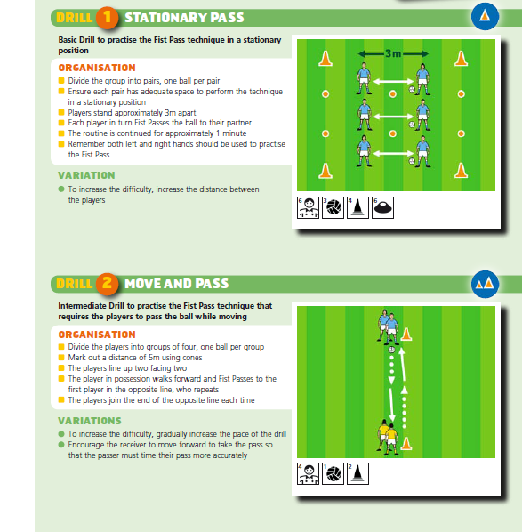**Practice the Technique**

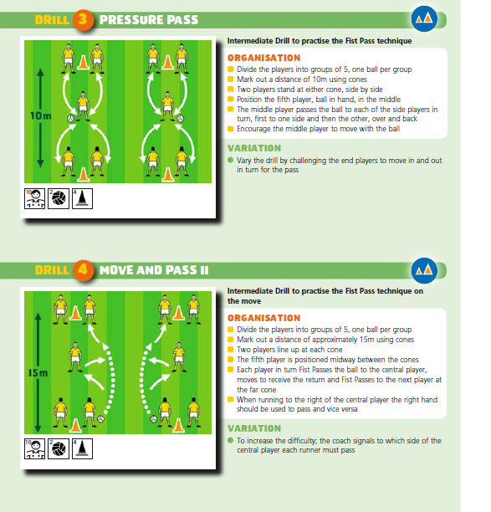

|  |
| --- |
| **Under 10/11 – Fist Pass** |

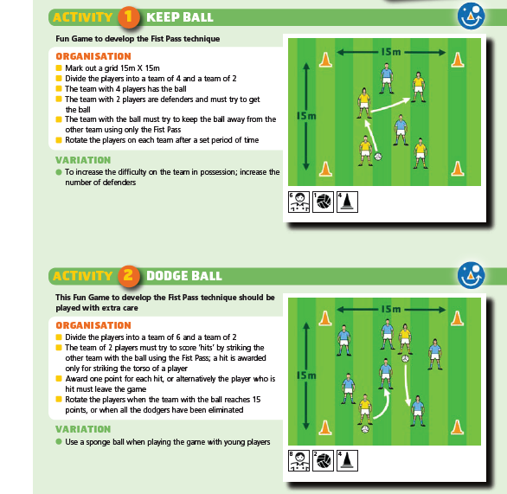**Develop the Skill**

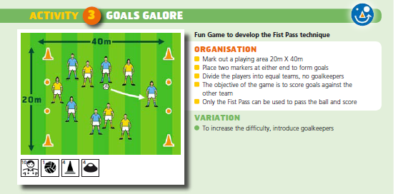

|  |
| --- |
| **Under 10/11 – Side to Side Charge** |

**Key Teaching Points**

* Move into position alongside the opponent
* Plant at least one foot on the ground

Keep the upper arm tight to the body, flexing the elbow to bring the forearm out and across the torso

* Shift the body weight towards the opponent, charging the opponent side to side

**Common Errors**

* Not shifting the body weight adequately toward the opponent: this may be because the player lacks confidence in the tackle situation
* To correct, introduce the player to the contact situation in a slow and controlled manner
* Charging the opponent in the front or in the back: this is a breach of the rules and may be penalised as an aggressive foul
* To correct, move into position alongside the opponent before performing the charge
* Not keeping at least one foot on the ground
* To correct, approach the opponent in a controlled manner and plant at least one foot on the ground before charging the opponent

|  |
| --- |
| **Under 10/11 – Side to Side Charge** |

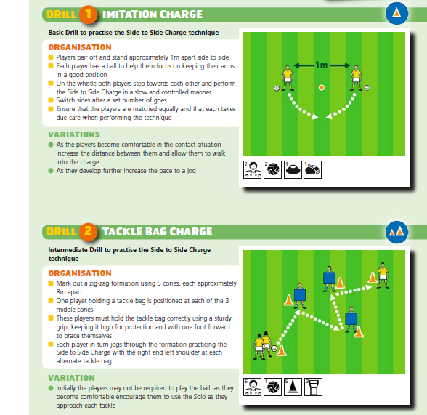**Practice the Technique**

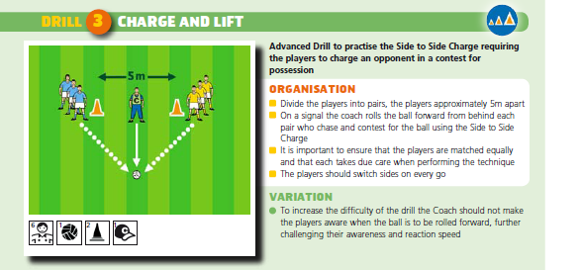

|  |
| --- |
| **Under 10/11 – Side to Side Charge** |

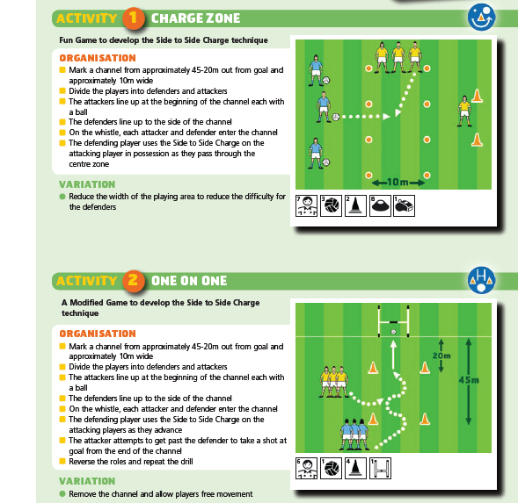**Develop the Skill**

